**Dual-Issue Superscalar MIPS Processor**

**Introduction:**

In this lab we are asked to make a dual-issue superscalar MIPS processor with the branch predictor. The dual-issue superscalar MIPS processor ideally issues two instructions per cycle. The superscalar MIPS processor we designed have ever component in the signal-issue 5-stage MIPS processor duplicated except program counter, instruction memory, register file and data memory. To make the dual-issue superscalar MIPS processor major changes must be made to the branch predictor, hazard unit, forwarding unit. **We did the extra credit mult and multu instructions.**

**Design methodology:**

In order to issue two instructions per cycle all the 5-stage pipeline is duplicated except the program counter, instruction memory, register file and data memory, so these units are added with additional ports to read or write two sets of data or instructions at the same time. Also, the caches for the memory stages are removed for simplicity. There are major changes to the data path, branch predictor, hazard unit, forwarding unit. **We also did the extra credit mult and multu instructions.**

The processor issues two instructions per cycle, so the entire pipeline is 10 instructions deep for the 5-stage dual-issue processor. The program counter in pipeline 2 fetch stage always equals to the program counter value plus four in pipeline 1 fetch stage, so for instructions that are in the same stage, the instruction in pipeline 1 is always older than the instruction in pipeline 2. They are arranged in the following order. The larger number the younger the instruction.

|  |  |  |  |  |  |
| --- | --- | --- | --- | --- | --- |
|  | F-stage | D-stage | E-stage | M-stage | W-stage |
| Pipeline 1 | Instruction 9 | Instruction 7 | Instruction 5 | Instruction 3 | Instruction 1 |
| Pipeline 2 | Instruction 10 | Instruction 8 | Instruction 6 | Instruction 4 | Instruction 2 |

**Hazard unit** is changed a lot. To make sure that the earlier instructions hit the memory stage or write back stage before later instruction, and cause write after write hazard, the hazard unit has to be redesigned. The stalling logic of avoiding write after write hazard is to stall all the instructions after the current instructions when an instruction needs to be stalled for load word, branch or other cases of data forwarding. The following is the pseudo-code of the new hazard unit.

lw stall pipeline 1 decode stage when:

read register of decode stage pipeline 1 equals write register in execution stage of pipeline 1 or pipeline 2 and instruction in them is a load word

lw stall pipeline 2 decode stage when:

read register of decode stage pipeline 2 equals write register in execution stage of pipeline 1 or pipeline 2 and instruction in them is a load word

or read register of decode stage pipeline 2 equals write register in decode stage of pipeline 1 which has load word instruction in it

also when there is an active branch in pipeline 1 decode stage, this stall is not performed

branch stall pipeline 1 decode stage when:

the write register in either pipeline1 or pipeline2’s execution or memory stage equals read register of pipeline 1 decode stage and the instruction in pipeline 1 decode stage is a branch

branch stall pipeline 2 decode stage when:

the write register in either pipeline1 or pipeline2’s execution or memory stage equals read register of pipeline 2 decode stage and the instruction in pipeline 2 decode stage is a branch

or read register of decode stage pipeline 2 equals write register in decode stage of pipeline 1, which has branch instruction in it

also when there is an active branch in pipeline 1 decode stage, this stall is not performed

pipeline 2 decode stage also stalls when:

a multiplication instruction is in pipeline 1 decode stage and a mflo or mfhi instruction is in pipeline 2 decode stage

also when there is an active branch in pipeline 1 decode stage, this stall is not performed

stall pipeline 1 execution stage when:

multiplication is performed in pipeline 1 execution stage

stall pipeline 2 execution stage when:

read register of execution stage pipeline 2 equals write register in execution stage of pipeline 1

or multiplication is performed in pipeline 2 execution stage

also when a stage of a pipeline is stalled, any stage of the two pipelines which contains instruction that is younger than the stalled instruction is stalled

memory stages and write back stages are never stalled

the flushing logics:

flush pipeline 1 decode stage when the branch predictor predicts the wrong branch or when pipeline 2 decode stage is stalled

flush pipeline 2 decode stage when the branch predictor predicts the wrong branch

flush pipeline 1 execution stage when pipeline 1 decode stage or pipeline 2 execution stage are stalled

flush pipeline 2 execution stage when pipeline 2 decode stage or when pipeline 1 decode stage have a branch instruction that branches

flush pipeline 1 memory stage when pipeline 1 execution stage is stalled

flush pipeline 2 memory stage when pipeline 1 execution stage or pipeline 2 execution stage is stalled

write back stage of the two pipelines are never flushed

**Forwarding unit** is also changed dramatically to suit the need of issuing two instructions per cycle. The duel-issuing structure means that there are 10 instructions in the pipeline concurrently. That means more possible places would the results need to be forwarded.

Decode stage of either pipeline 1 or pipeline 2 needs forwarding from both memory stage of pipeline 1 and pipeline 2. Since pipeline 2 memory stage holds instruction younger than pipeline 1 memory stage, if both memory stage needs to forward to the same place, the data in the pipeline 2 memory stage will be forwarded.

Execution stage of either pipeline 1 or pipeline 2 needs forwarding from four places, both memory stage and write back stage of pipeline 1 and pipeline 2. If some of these four stages need to forward data to the same place, only the one holds the youngest instruction will be forwarded.

**Branch predictor** also needs to be changed two incorporate the possibility of having two concurrent branches. When there is only one branch in one of the decode stages, the branch predictor works the same way as it used to be, but both decode stages in pipeline 1 and pipeline 2 needs to be flushed at the same time when the branch is predicted wrong. The branch predictor can now predict two branches for both pipeline 1 and 2 at the same time. However, it is only possible that one of these branches is a legitimate branch even both of them triggers branching in the decode stage, because if the first branch is branched, the next branch right after it should not be run even if it actually branches.

The branch predictor now always loads the target PC and target PC + 4 into fetch stage of pipeline 1 and 2, regardless to the prediction of the branch prediction of pipeline 2, if the branch/jump in the pipeline 1 predicts branching. Only when the instruction in pipeline 1 does not predict a branch, the PCs of fetch stage pipeline 1 and 2 would be updated with target PC and target PC + 4 of the branch instruction in pipeline2, if the branch predictor predicts the branch in pipeline2 needs to be taken.

The updating logic of the global history register and the pattern history table also changes. If the branch is in pipeline 1 decode stage, it is always updated according to the original rule of updating global history register and pattern history table in single-issue processor. If the branch is in pipeline 2 decode stage, it is only updated when the instruction in pipeline 1 decode stage is either not a branch/jump or it is a branch instruction, but the branch is not taken.

**Multiplier** also changes. Each execution stage of different pipeline has their own multiplier, but they share the same lo and hi register. Either multiplier from different pipeline will update the lo and hi register right after they finish multiplication.

If both execution stage of the two pipelines are doing multiplication at the same time, only the result of multiplier in pipeline 2 will be written in to lo and hi register, because the instruction in pipeline 2 is the youngest.

**Instructions:**

**R-type instructions**

Since the processor issues two instructions per cycle, R-type instructions will be executed parallelly with other R-type instructions or other type of instructions. The forwarding and stalling logic needs to be changed, so the instruction still stuck in the pipeline change have the correct register value forwarded to them. The major changes are to the instructions mult, multu, mflo and mfhi.

**add addu sub subu and or xor xnor slt sltu**

These instructions work the same way as they used to be. Only the forwarding and stalling of these instruction changes.

**mult multu**

Two multipliers now share the same lo and hi register. They can both modify the contents in the two register. If both of they are trying to modify the lo and hi register, the youngest instruction will over write the older one.

**mflo mfhi**

Since there is only one pair of lo and hi registers data path, Instruction mflo or mfhi can load the same value regardless whether it is in pipeline 1 and pipeline 2. Also, if mflo or mfhi enter the decode stage at the same time, mflo or mfhi will be stalled for one cycle, so they do not entire execution stage at the same time.

**I-type instructions**

The wording of I-type instructions does not change much except their forwarding and stalling. The only major changes to the working of i-type instructions are to bne and beq, since the branch predicting works differently in duel-issue processor.

**addi addiu andi ori xori slti sltiu lui lw sw**

These instructions work the same way as they used to be. Only the forwarding and stalling of these instruction changes.

**bne beq**

The results of instruction bne and beq is predicted in the fetch stage. The new branch predictor can new make two prediction at the same time, if two branches are adjacent to each other and entire the pipeline at the same time.

The branch predictor always loads the target PC and target PC + 4 into fetch stage of pipeline 1 and 2, regardless to the prediction of the branch prediction of pipeline 2, if the branch/jump in the pipeline 1 predicts branching. Only when the instruction in pipeline 1 does not predict a branch, the PCs of fetch stage pipeline 1 and 2 would be updated with target PC and target PC + 4 of the branch instruction in pipeline2, if the branch predictor predicts the branch in pipeline2 needs to be taken.

Pipeline 1 and 2’s decode stage is flushed when the branch predictor predicts the wrong branch. In order to flush out the instruction in pipeline 2 decode stage following an active branch in pipeline 1 decode stage that needs to be taken, the stalling of pipeline 2 decode stage is cancelled and flush signal in pipeline2 execution stage is pull.

**J-type instruction j**

The branch prediction, stalling and flushing are the same as those for branch instruction.

**Step1:** Redesign your architecture to support double issuing.

The 5-stage pipeline is duplicated except the program counter, instruction memory, register file and data memory, so these units are added with additional ports to read or write two sets of data or instructions at the same time.

**Step2:** Test your existing design by running a simple two consecutive ADD instructions.

The program is 10 consecutive addi instructions:

0x20080001 addi $t0, $zero, 1

0x20090002 addi $t1, $zero, 2

0x20080003 addi $t0, $zero, 3

0x20090004 addi $t1, $zero, 4

0x20080005 addi $t0, $zero, 5

0x20090006 addi $t1, $zero, 6

0x20080007 addi $t0, $zero, 7

0x20090008 addi $t1, $zero, 8

0x20080009 addi $t0, $zero, 9

0x2009000a addi $t1, $zero, 10

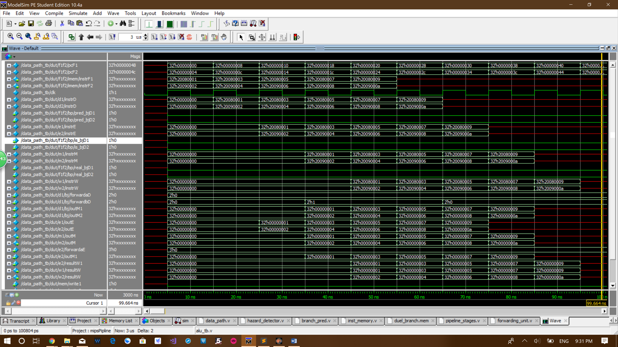**Waveform:**

The signal f1f2/pcF1 and f1f2/pcF2 are the program counter value of pipeline 1 and pipeline 2. As you can see one cycle last for 10 ns. The instructions run in total 5 cycles because there are 10 adds. The value of f1f2/pcF1 is incremented by 8 every cycle as expected and the value of f1f2/pcF2 is always f1f2/pcF1 + 4.

As you can see, d1/instrD is the instruction in the decode stage of pipeline 1. The naming convention is the same for d2/instrD, e1/instrE, e2/instrE, m1/instrM, m2/instrM, w1/instrW and w2/instrW. You can see on the wave form pattern shift exactly one cycle to the right when propagated to the next stage of the pipeline.

Now look at the two signals w1/resultW and w2/resultW at the bottom. Start from 45ns to 95 ns, these 5 cycles show the correct number from 1 to 10 written back to the register file. Each cycle, two results are written back concurrently as expected.

**Step3:** Increase the number of instructions to test the pipeline, but only simple instructions not hazard.

Step 3, 5, 6 are tested together. They share the same waveform. The waveform is in step 6.

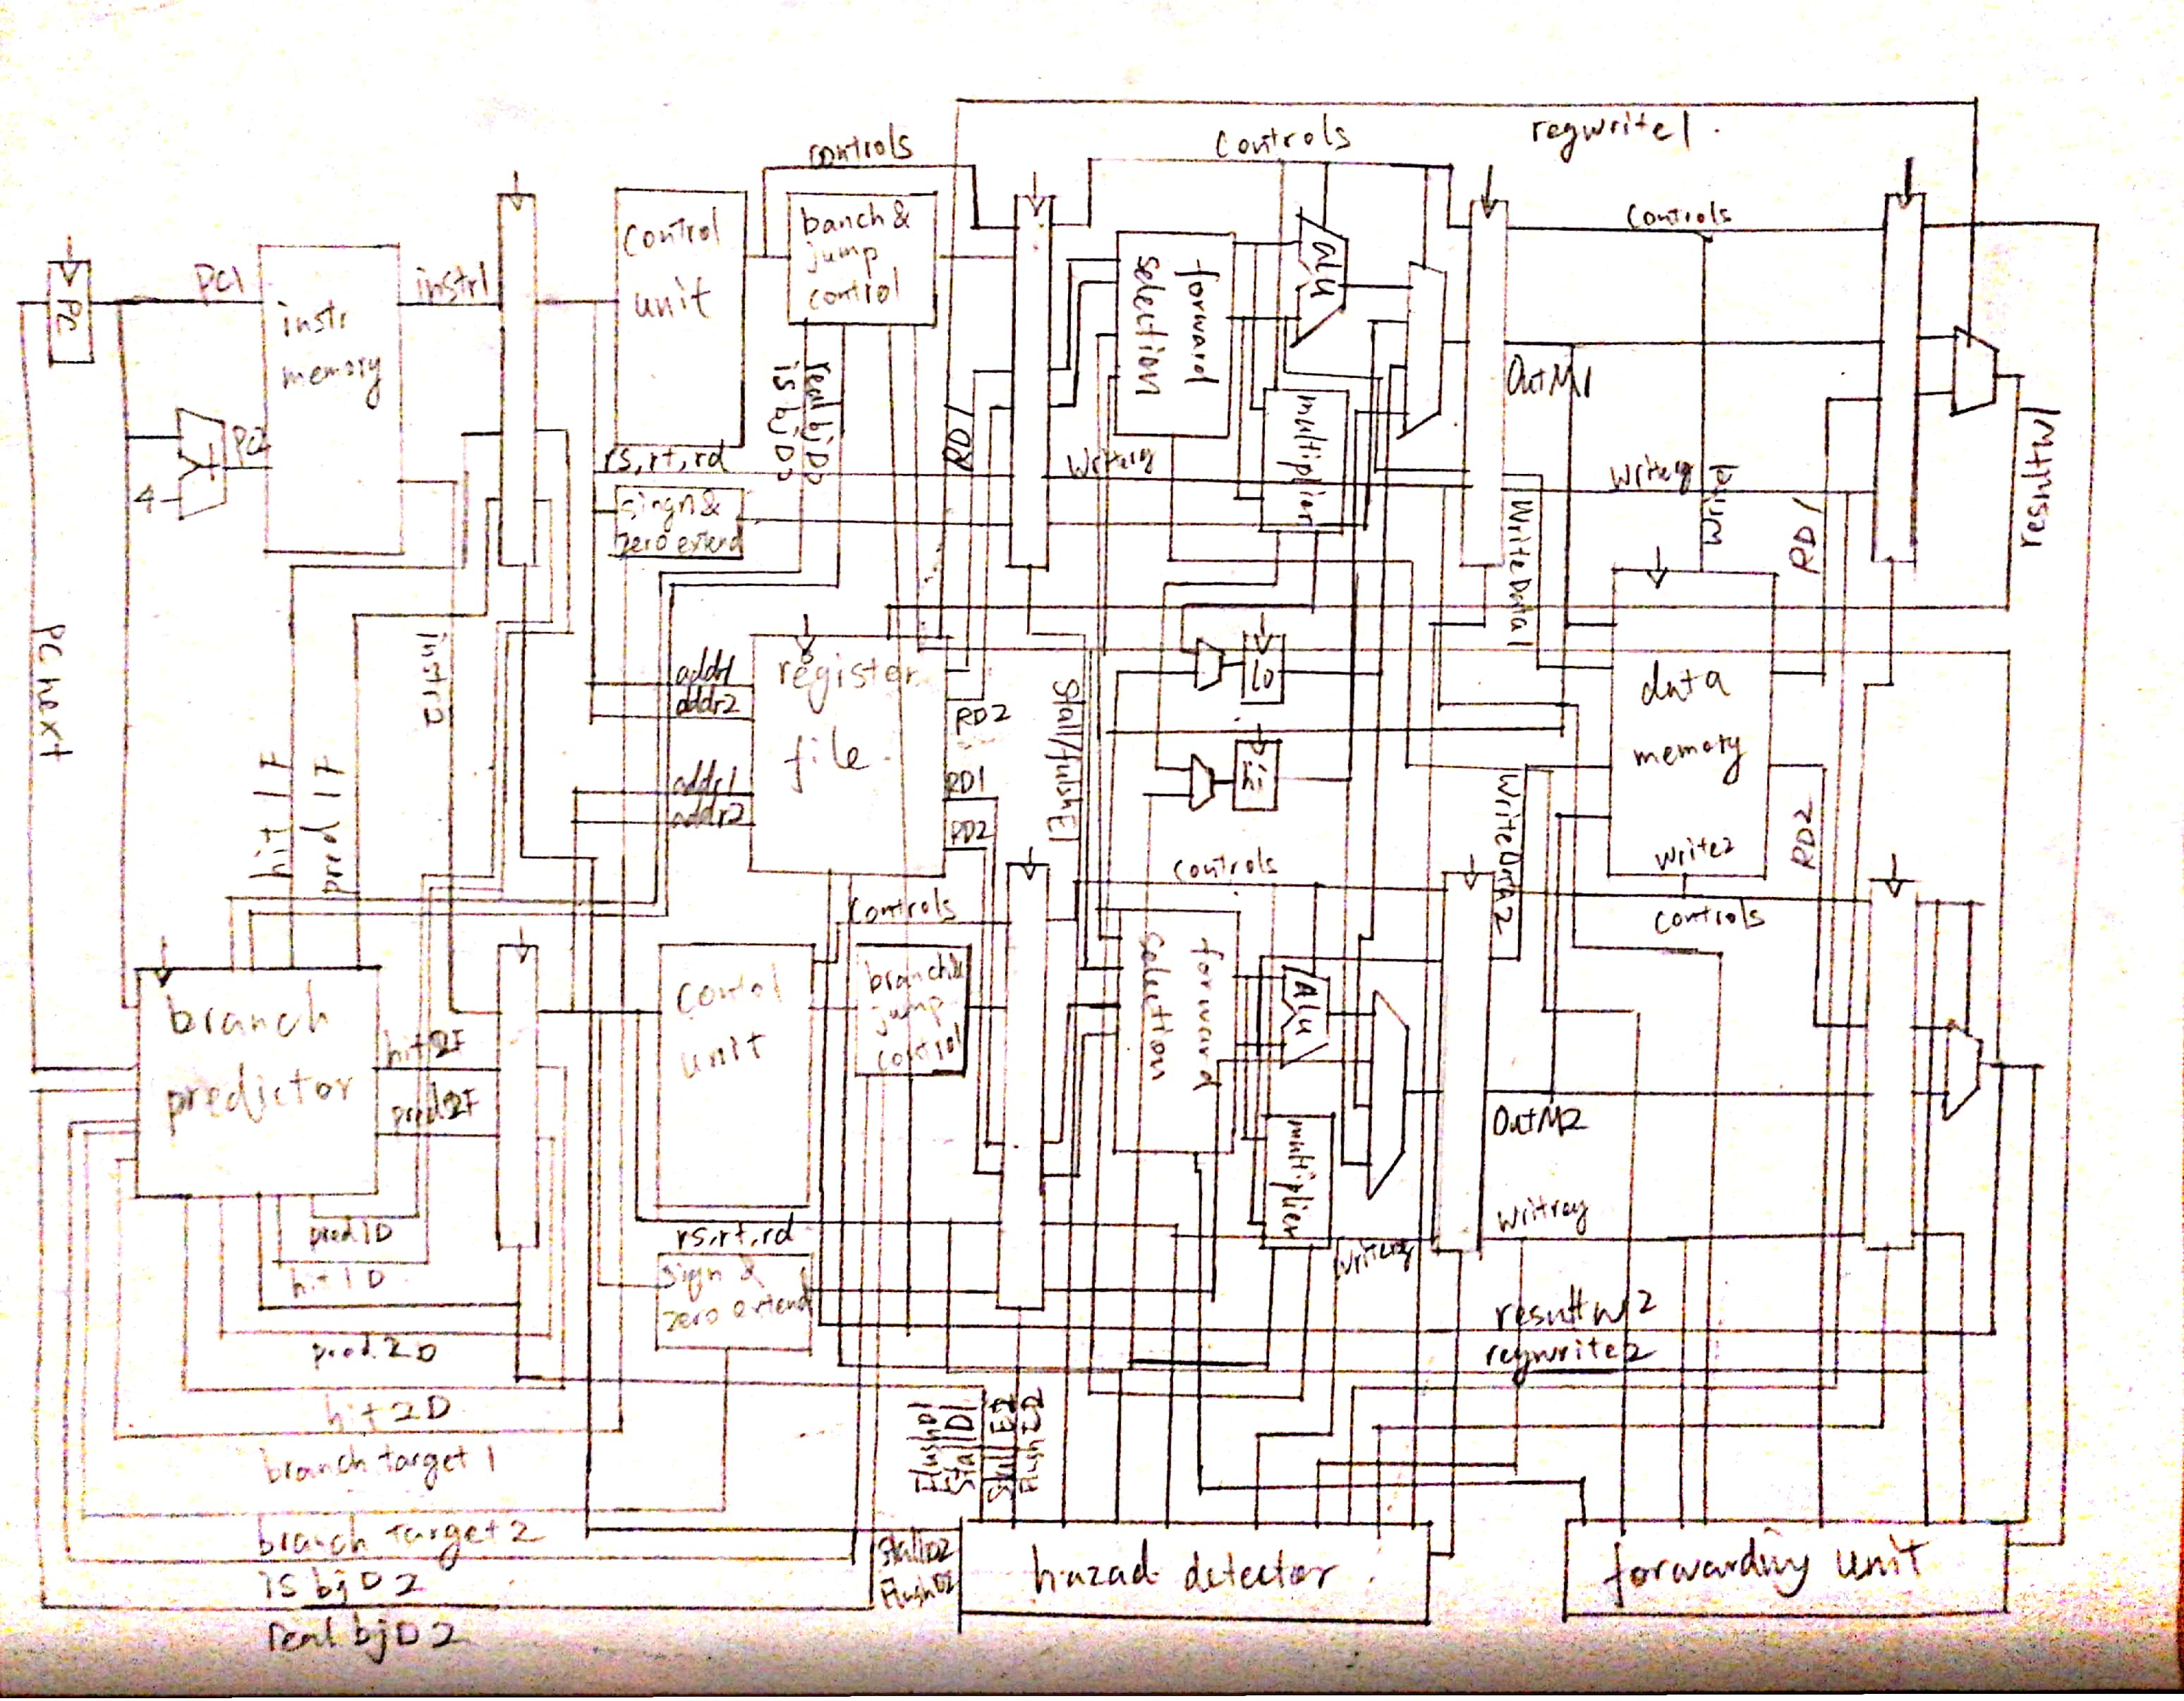**Step4:** Sketch a complete diagram of your design and identify all possible hazards.

**lw stall hazard:**

|  |  |  |  |  |  |
| --- | --- | --- | --- | --- | --- |
|  | F-stage | D-stage | E-stage | M-stage | W-stage |
| Pipeline 1 | Instruction 9 | lw | Instruction 5 | Instruction 3 | Instruction 1 |
| Pipeline 2 | Instruction 10 | Instruction 8 | Instruction 6 | Instruction 4 | Instruction 2 |

If lw is in d1 and there is a dependency between lw and the red instruction in d2, d2 and all stage with instruction number greater than 8 will be stalled, and d1, e2 will be flushed at the same time.

|  |  |  |  |  |  |
| --- | --- | --- | --- | --- | --- |
|  | F-stage | D-stage | E-stage | M-stage | W-stage |
| Pipeline 1 | Instruction 9 | Instruction 7 | lw | Instruction 3 | Instruction 1 |
| Pipeline 2 | Instruction 10 | Instruction 8 | Instruction 6 | Instruction 4 | Instruction 2 |

If lw is in e1 and there is a dependency between lw and the red instruction in d2, d2 and all stage with instruction number greater than 8 will be stalled, and d1, e2 will be flushed at the same time.

|  |  |  |  |  |  |
| --- | --- | --- | --- | --- | --- |
|  | F-stage | D-stage | E-stage | M-stage | W-stage |
| Pipeline 1 | Instruction 9 | Instruction 7 | Instruction 5 | Instruction 3 | Instruction 1 |
| Pipeline 2 | Instruction 10 | Instruction 8 | lw | Instruction 4 | Instruction 2 |

If lw is in e2 and there is a dependency between lw and the red instruction in d2, d2 and all stage with instruction number greater than 8 will be stalled, and d1, e2 will be flushed at the same time.

|  |  |  |  |  |  |
| --- | --- | --- | --- | --- | --- |
|  | F-stage | D-stage | E-stage | M-stage | W-stage |
| Pipeline 1 | Instruction 9 | Instruction 7 | lw | Instruction 3 | Instruction 1 |
| Pipeline 2 | Instruction 10 | Instruction 8 | Instruction 6 | Instruction 4 | Instruction 2 |

If lw is in e1 and there is a dependency between lw and the red instruction in d1, d1 and all stage with instruction number greater than 7 will be stalled, and e1, e2 will be flushed at the same time.

|  |  |  |  |  |  |
| --- | --- | --- | --- | --- | --- |
|  | F-stage | D-stage | E-stage | M-stage | W-stage |
| Pipeline 1 | Instruction 9 | Instruction 7 | Instruction 5 | Instruction 3 | Instruction 1 |
| Pipeline 2 | Instruction 10 | Instruction 8 | lw | Instruction 4 | Instruction 2 |

If lw is in e2 and there is a dependency between lw and the red instruction in d1, d1 and all stage with instruction number greater than 7 will be stalled, and e1, e2 will be flushed at the same time.

**Branch stall hazard:**

|  |  |  |  |  |  |
| --- | --- | --- | --- | --- | --- |
|  | F-stage | D-stage | E-stage | M-stage | W-stage |
| Pipeline 1 | Instruction 9 | Instruction 7 | Instruction 5 | Instruction 3 | Instruction 1 |
| Pipeline 2 | Instruction 10 | branch | Instruction 6 | Instruction 4 | Instruction 2 |

If branch is in d2 and there is a dependency between branch and the red instruction in d1, d2 and all stage with instruction number greater than 8 will be stalled, and d1, e2 will be flushed at the same time.

|  |  |  |  |  |  |
| --- | --- | --- | --- | --- | --- |
|  | F-stage | D-stage | E-stage | M-stage | W-stage |
| Pipeline 1 | Instruction 9 | Instruction 7 | Instruction5 | Instruction 3 | Instruction 1 |
| Pipeline 2 | Instruction 10 | branch | Instruction 6 | Instruction 4 | Instruction 2 |

If branch is in d2 and there is a dependency between branch and the red instruction in e2, d2 and all stage with instruction number greater than 8 will be stalled, and d1, e2 will be flushed at the same time.

|  |  |  |  |  |  |
| --- | --- | --- | --- | --- | --- |
|  | F-stage | D-stage | E-stage | M-stage | W-stage |
| Pipeline 1 | Instruction 9 | Instruction 7 | Instruction 5 | lw | Instruction 1 |
| Pipeline 2 | Instruction 10 | branch | Instruction 6 | Instruction 4 | Instruction 2 |

If branch is in d2 and there is a dependency between branch and the red instruction lw in m2, d2 and all stage with instruction number greater than 8 will be stalled, and d1, e2 will be flushed at the same time.

|  |  |  |  |  |  |
| --- | --- | --- | --- | --- | --- |
|  | F-stage | D-stage | E-stage | M-stage | W-stage |
| Pipeline 1 | Instruction 9 | Instruction 7 | Instruction 5 | Instruction 3 | Instruction 1 |
| Pipeline 2 | Instruction 10 | branch | Instruction 6 | Instruction 4 | Instruction 2 |

If branch is in d2 and there is a dependency between branch and the red instruction in e2, d2 and all stage with instruction number greater than 8 will be stalled, and d1, e2 will be flushed at the same time.

|  |  |  |  |  |  |
| --- | --- | --- | --- | --- | --- |
|  | F-stage | D-stage | E-stage | M-stage | W-stage |
| Pipeline 1 | Instruction 9 | Instruction 7 | Instruction 5 | Instruction 3 | Instruction 1 |
| Pipeline 2 | Instruction 10 | branch | Instruction 6 | lw | Instruction 2 |

If branch is in d2 and there is a dependency between branch and the red instruction lw in m2, d2 and all stage with instruction number greater than 8 will be stalled, and d1, e2 will be flushed at the same time.

|  |  |  |  |  |  |
| --- | --- | --- | --- | --- | --- |
|  | F-stage | D-stage | E-stage | M-stage | W-stage |
| Pipeline 1 | Instruction 9 | branch | Instruction5 | Instruction 3 | Instruction 1 |
| Pipeline 2 | Instruction 10 | Instruction 8 | Instruction 6 | Instruction 4 | Instruction 2 |

If branch is in d1 and there is a dependency between branch and the red instruction in e2, d1 and all stage with instruction number greater than 7 will be stalled, and e1, e2 will be flushed at the same time.

|  |  |  |  |  |  |
| --- | --- | --- | --- | --- | --- |
|  | F-stage | D-stage | E-stage | M-stage | W-stage |
| Pipeline 1 | Instruction 9 | branch | Instruction 5 | lw | Instruction 1 |
| Pipeline 2 | Instruction 10 | Instruction 8 | Instruction 6 | Instruction 4 | Instruction 2 |

If branch is in d1 and there is a dependency between branch and the red instruction lw in m2, d1 and all stage with instruction number greater than 7 will be stalled, and e1, e2 will be flushed at the same time.

|  |  |  |  |  |  |
| --- | --- | --- | --- | --- | --- |
|  | F-stage | D-stage | E-stage | M-stage | W-stage |
| Pipeline 1 | Instruction 9 | branch | Instruction 5 | Instruction 3 | Instruction 1 |
| Pipeline 2 | Instruction 10 | Instruction 8 | Instruction 6 | Instruction 4 | Instruction 2 |

If branch is in d1 and there is a dependency between branch and the red instruction in e2, d1 and all stage with instruction number greater than 7 will be stalled, and e1, e2 will be flushed at the same time.

|  |  |  |  |  |  |
| --- | --- | --- | --- | --- | --- |
|  | F-stage | D-stage | E-stage | M-stage | W-stage |
| Pipeline 1 | Instruction 9 | branch | Instruction 5 | Instruction 3 | Instruction 1 |
| Pipeline 2 | Instruction 10 | Instruction 8 | Instruction 6 | lw | Instruction 2 |

If branch is in d1 and there is a dependency between branch and the red instruction lw in m2, d1 and all stage with instruction number greater than 7 will be stalled, and e1, e2 will be flushed at the same time.

**Execution stall hazard:**

|  |  |  |  |  |  |
| --- | --- | --- | --- | --- | --- |
|  | F-stage | D-stage | E-stage | M-stage | W-stage |
| Pipeline 1 | Instruction 9 | Instruction 7 | Instruction 5 | Instruction 3 | Instruction 1 |
| Pipeline 2 | Instruction 10 | Instruction 8 | Instruction 6 | Instruction 4 | Instruction 2 |

If instruction 8 have dependency on instruction 7, d2 and all stage with instruction number greater than 8 will be stalled, and d1, e2 will be flushed at the same time.

**Decode stage forwarding:**

|  |  |  |  |  |  |
| --- | --- | --- | --- | --- | --- |
|  | F-stage | D-stage | E-stage | M-stage | W-stage |
| Pipeline 1 | Instruction 9 | Instruction 7 | Instruction 5 | Instruction 3 | Instruction 1 |
| Pipeline 2 | Instruction 10 | Instruction 8 | Instruction 6 | Instruction 4 | Instruction 2 |

Instruction colored red will have its result forwarded to any of the two decode stages colored with blue. If decode stage have dependency with both instruction 3 and 4, only instruction 4 will be forwarded, since it is the youngest.

**Execution stage forwarding:**

|  |  |  |  |  |  |
| --- | --- | --- | --- | --- | --- |
|  | F-stage | D-stage | E-stage | M-stage | W-stage |
| Pipeline 1 | Instruction 9 | Instruction 7 | Instruction 5 | Instruction 3 | Instruction 1 |
| Pipeline 2 | Instruction 10 | Instruction 8 | Instruction 6 | Instruction 4 | Instruction 2 |

Instruction colored red will have its result forwarded to any of the two execution stages colored with blue. If execution stage have dependency with both more than 1 instructions, only youngest instruction will be forwarded.

**Step5:** Take care of hazards by either stalling or forwarding.

Step 3, 5, 6 are tested together. They share the same waveform. The waveform is in step 6.

**Hazard detector code:**

module hazard_detector(input multD1, multD2,

input [1:0] out_selD1, out_selD2,

input is_bjD1, real_bjD1,

input branchD1, branchD2, memtoregD1, memtoregD2, regwriteD1, regwriteD2,

input [4:0] rsD1, rtD1, writeregD1, rsD2, rtD2, writeregD2,

input memtoregE1, regwriteE1, mult_stallE1,

input memtoregE2, regwriteE2, mult_stallE2,

input [4:0] rsE1, rtE1, writeregE1, rsE2, rtE2, writeregE2,

input memtoregM1, memtoregM2,

input [4:0] writeregM1, writeregM2,

output stall_f,

output stall_d1, stall_e1, stall_m1, stall_w1,

output stall_d2, stall_e2, stall_m2, stall_w2,

output flush_d1, flush_e1, flush_m1, flush_w1,

output flush_d2, flush_e2, flush_m2, flush_w2);

//lw stall

wire lw_stall1; assign lw_stall1 = ( (((rsD1 == writeregE1) | (rtD1 == writeregE1)) & memtoregE1) |

(((rsD1 == writeregE2) | (rtD1 == writeregE2)) & memtoregE2) );

wire lw_stall2; assign lw_stall2 = ( (((rsD2 == writeregD1) | (rtD2 == writeregD1)) & memtoregD1) |

(((rsD2 == writeregE1) | (rtD2 == writeregE1)) & memtoregE1) |

(((rsD2 == writeregE2) | (rtD2 == writeregE2)) & memtoregE2) );

//branch stall

wire bscE1; assign bscE1 = ( (((rsD1 == writeregE1) | (rtD1 == writeregE1)) & regwriteE1) |

(((rsD1 == writeregE2) | (rtD1 == writeregE2)) & regwriteE2) );

wire bscM1; assign bscM1 = ( (((rsD1 == writeregM1) | (rtD1 == writeregM1)) & memtoregM1) |

(((rsD1 == writeregM2) | (rtD1 == writeregM2)) & memtoregM2) );

wire branch_stall1; assign branch_stall1 = branchD1 & (bscE1 | bscM1);

wire bscD2; assign bscD2 = ((rsD2 == writeregD1) | (rtD2 == writeregD1)) & regwriteD1;

wire bscE2; assign bscE2 = ( (((rsD2 == writeregE1) | (rtD2 == writeregE1)) & regwriteE1) |

(((rsD2 == writeregE2) | (rtD2 == writeregE2)) & regwriteE2) );

wire bscM2; assign bscM2 = ( (((rsD2 == writeregM1) | (rtD2 == writeregM1)) & memtoregM1) |

(((rsD2 == writeregM2) | (rtD2 == writeregM2)) & memtoregM2) );

wire branch_stall2; assign branch_stall2 = branchD2 & (bscD2 | bscE2 | bscM2);

//execution stall

wire exe_stall2; assign exe_stall2 = ((rsE2 == writeregE1) | (rtE2 == writeregE1)) & regwriteE1;

//stalls

assign stall_w1 = 0;

assign stall_w2 = 0;

assign stall_m1 = 0;

assign stall_m2 = 0;

assign stall_e1 = mult_stallE1;

assign stall_e2 = stall_e1 | exe_stall2 | mult_stallE2;

assign stall_d1 = stall_e2 | lw_stall1 | branch_stall1;

assign stall_d2 = stall_d1 | ((lw_stall2 | branch_stall2) & ~(is_bjD1 & real_bjD1))

| (multD1 & (out_selD2 == 2'b10)|(out_selD2 == 2'b11));

assign stall_f = stall_d2;

//flushes

assign flush_w1 = 0;

assign flush_w2 = 0;

assign flush_m1 = stall_e1;

assign flush_m2 = stall_e1 | stall_e2;

assign flush_e1 = stall_d1 | stall_e2;

assign flush_e2 = stall_d1 | stall_d2 | (is_bjD1 & real_bjD1);

assign flush_d1 = stall_d2;

assign flush_d2 = 0;

endmodule

**Forwarding unit code:**

module forwarding_unit(input [4:0] rsD1, rtD1, rsD2, rtD2,

input [4:0] rsE1, rtE1, rsE2, rtE2,

input regwriteM1, regwriteM2, input [4:0] writeregM1, writeregM2,

input regwriteW1, regwriteW2, input [4:0] writeregW1, writeregW2,

output reg [1:0] forwardaD1, forwardbD1, forwardaD2, forwardbD2,

output reg [2:0] forwardaE1, forwardbE1, forwardaE2, forwardbE2);

always @(*) begin

//forward to decode stage

if(rsD1 != 0) begin //outM1, outM2,

if (rsD1 == writeregM2 & regwriteM2) forwardaD1 = 2'd2;

else if(rsD1 == writeregM1 & regwriteM1) forwardaD1 = 2'd1;

else forwardaD1 = 2'd0;

end

else forwardaD1 = 2'd0;

if(rtD1 != 0) begin

if (rtD1 == writeregM2 & regwriteM2) forwardbD1 = 2'd2;

else if(rtD1 == writeregM1 & regwriteM1) forwardbD1 = 2'd1;

else forwardbD1 = 2'd0;

end

else forwardbD1 = 2'd0;

if(rsD2 != 0) begin //outM1, outM2,

if (rsD2 == writeregM2 & regwriteM2) forwardaD2 = 2'd2;

else if(rsD2 == writeregM1 & regwriteM1) forwardaD2 = 2'd1;

else forwardaD2 = 2'd0;

end

else forwardaD2 = 2'd0;

if(rtD2 != 0) begin

if (rtD2 == writeregM2 & regwriteM2) forwardbD2 = 2'd2;

else if(rtD2 == writeregM1 & regwriteM1) forwardbD2 = 2'd1;

else forwardbD2 = 2'd0;

end

else forwardbD2 = 2'd0;

//forward to execution stage

if(rsE1 != 0) begin //outM1, resultW1, outM2, resultW2,

if (rsE1 == writeregM2 & regwriteM2) forwardaE1 = 3'd3;

else if(rsE1 == writeregM1 & regwriteM1) forwardaE1 = 3'd1;

else if(rsE1 == writeregW2 & regwriteW2) forwardaE1 = 3'd4;

else if(rsE1 == writeregW1 & regwriteW1) forwardaE1 = 3'd2;

else forwardaE1 = 3'd0;

end

else forwardaE1 = 2'd0;

if(rtE1 != 0) begin

if (rtE1 == writeregM2 & regwriteM2) forwardbE1 = 3'd3;

else if(rtE1 == writeregM1 & regwriteM1) forwardbE1 = 3'd1;

else if(rtE1 == writeregW2 & regwriteW2) forwardbE1 = 3'd4;

else if(rtE1 == writeregW1 & regwriteW1) forwardbE1 = 3'd2;

else forwardbE1 = 3'd0;

end

else forwardbE1 = 3'd0;

if(rsE2 != 0) begin //outM1, resultW1, outM2, resultW2,

if (rsE2 == writeregM2 & regwriteM2) forwardaE2 = 3'd3;

else if(rsE2 == writeregM1 & regwriteM1) forwardaE2 = 3'd1;

else if(rsE2 == writeregW2 & regwriteW2) forwardaE2 = 3'd4;

else if(rsE2 == writeregW1 & regwriteW1) forwardaE2 = 3'd2;

else forwardaE2 = 3'd0;

end

else forwardaE2 = 3'd0;

if(rtE2 != 0) begin

if (rtE2 == writeregM2 & regwriteM2) forwardbE2 = 3'd3;

else if(rtE2 == writeregM1 & regwriteM1) forwardbE2 = 3'd1;

else if(rtE2 == writeregW2 & regwriteW2) forwardbE2 = 3'd4;

else if(rtE2 == writeregW1 & regwriteW1) forwardbE2 = 3'd2;

else forwardbE2 = 3'd0;

end

else forwardbE2 = 3'd0;

end

endmodule

**Step6:** Take care of other details such as branch predictions.

Some of the flushing logic are controlled by branch predictor. The two decode stages have flushing logic from branch predictor combined with flushing logic of decode stage in the hazard unit.

|  |  |  |  |  |  |
| --- | --- | --- | --- | --- | --- |
|  | F-stage | D-stage | E-stage | M-stage | W-stage |
| Pipeline 1 | Instruction 9 | branch | Instruction 5 | Instruction 3 | Instruction 1 |
| Pipeline 2 | Instruction 10 | Branch/Instruction 8 | Instruction 6 | Instruction 4 | Instruction 2 |

The branch predictor now always loads the target PC and target PC + 4 into fetch stage of pipeline 1 and 2, regardless to the prediction of the branch prediction of pipeline 2 (the blue instruction), if the branch/jump in the pipeline 1 predicts branching (the red instruction).

Whenever the branch in pipeline 1 decode stage (the red instruction) actually is taken, pipeline 2 execution stage (the green stage) needs to be flushed to prevent the instruction in pipeline 2 decode stage (the blue instruction) from entering the execution stage.

Only when the instruction in pipeline 1 does not predict a branch, the PCs of fetch stage pipeline 1 and 2 would be updated with target PC and target PC + 4 of the branch instruction in pipeline2, if the branch predictor predicts the branch in pipeline2 needs to be taken.

The updating logic of the global history register and the pattern history table also changes. If the branch is in pipeline 1 decode stage, it is always updated according to the original rule of updating global history register and pattern history table in single-issue processor. If the branch is in pipeline 2 decode stage, it is only updated when the instruction in pipeline 1 decode stage is either not a branch/jump or it is a branch instruction, but the branch is not taken.

**Branch predictor code:**

module branch_pred(input clk, reset, stall_f,

input hitD1, pred_bjD1, is_bjD1, real_bjD1,

input hitD2, pred_bjD2, is_bjD2, real_bjD2,

input [31:0] pcF1, pcD1, target_pcD1,

input [31:0] pcF2, pcD2, target_pcD2,

output hitF1, pred_bjF1, output reg flush_d1F,

output hitF2, pred_bjF2, output reg flush_d2F,

output reg [31:0] pc_next1);

wire [31:0] target_pcF1; // target_pcF is the target pc stored in branch target buffer

wire [31:0] target_pcF2;

branch_target_buffer btb(clk, reset, stall_f,

hitD1, is_bjD1, real_bjD1,

hitD2, is_bjD2, real_bjD2,

pcF1, pcD1, target_pcD1,

pcF2, pcD2, target_pcD2,

hitF1, hitF2,

target_pcF1,

target_pcF2);

global_history_predictor ghp(clk, reset, stall_f,

is_bjD1, real_bjD1,

is_bjD2, real_bjD2,

pcF1, pcD1,

pcF2, pcD2,

pred_bjF1,

pred_bjF2);

always @(*) begin

if(~is_bjD1 & ~is_bjD2) begin //if both instrutions in decode stage are not branch

if (hitF1 & pred_bjF1) begin pc_next1 <= target_pcF1; flush_d1F <= 0; flush_d2F <= 0; end

else if(hitF2 & pred_bjF2) begin pc_next1 <= target_pcF2; flush_d1F <= 0; flush_d2F <= 0; end

else begin pc_next1 <= pcF1 + 8; flush_d1F <= 0; flush_d2F <= 0; end

end

else begin

if(hitD1 & pred_bjD1) begin //if predicted d1 branch takes

if (real_bjD1) begin //if d1 actually takes

if (hitF1 & pred_bjF1) begin pc_next1 <= target_pcF1; flush_d1F <= 0; flush_d2F <= 0; end

else if(hitF2 & pred_bjF2) begin pc_next1 <= target_pcF2; flush_d1F <= 0; flush_d2F <= 0; end

else begin pc_next1 <= pcF1 + 8; flush_d1F <= 0; flush_d2F <= 0; end

end

else if(real_bjD2) begin pc_next1 <= target_pcD2; flush_d1F <= 1; flush_d2F <= 1; end //if d2 actually takes

else begin pc_next1 <= pcD1 + 8; flush_d1F <= 1; flush_d2F <= 1; end //none of them takes

end

else if(hitD2 & pred_bjD2) begin //if predicted d2 branch takes

if (real_bjD1) begin pc_next1 <= target_pcD1; flush_d1F <= 1; flush_d2F <= 1; end //if d1 actually takes

else if(real_bjD2) begin //if d2 actually takes

if (hitF1 & pred_bjF1) begin pc_next1 <= target_pcF1; flush_d1F <= 0; flush_d2F <= 0; end

else if(hitF2 & pred_bjF2) begin pc_next1 <= target_pcF2; flush_d1F <= 0; flush_d2F <= 0; end

else begin pc_next1 <= pcF1 + 8; flush_d1F <= 0; flush_d2F <= 0; end

end

else begin pc_next1 <= pcD1 + 8; flush_d1F <= 1; flush_d2F <= 1; end //none of them takes

end

else begin //predicted none of them takes

if (real_bjD1) begin pc_next1 <= target_pcD1; flush_d1F <= 1; flush_d2F <= 1; end //if d1 actually takes

else if(real_bjD2) begin pc_next1 <= target_pcD2; flush_d1F <= 1; flush_d2F <= 1; end //if d2 actually takes

else begin //none of them takes

if (hitF1 & pred_bjF1) begin pc_next1 <= target_pcF1; flush_d1F <= 0; flush_d2F <= 0; end

else if(hitF2 & pred_bjF2) begin pc_next1 <= target_pcF2; flush_d1F <= 0; flush_d2F <= 0; end

else begin pc_next1 <= pcF1 + 8; flush_d1F <= 0; flush_d2F <= 0; end

end

end

end

end

endmodule

module branch_target_buffer(input clk, reset, stall_f,

input hitD1, is_bjD1, real_bjD1,

input hitD2, is_bjD2, real_bjD2,

input [31:0] pcF1, pcD1, target_pcD1,

input [31:0] pcF2, pcD2, target_pcD2,

output hitF1, hitF2,

output [31:0] target_pcF1,

output [31:0] target_pcF2);

//integer a = 0;

wire [31:3] tagF1; assign tagF1 = pcF1[31:3];

wire [2:0] indexF1; assign indexF1 = pcF1[2:0];

wire [31:3] tagD1; assign tagD1 = pcD1[31:3];

wire [2:0] indexD1; assign indexD1 = pcD1[2:0];

wire [31:3] tagF2; assign tagF2 = pcF2[31:3];

wire [2:0] indexF2; assign indexF2 = pcF2[2:0];

wire [31:3] tagD2; assign tagD2 = pcD2[31:3];

wire [2:0] indexD2; assign indexD2 = pcD2[2:0];

reg v [0:7]; reg [31:0] b_pc_tag [0:7]; reg [31:0] t_pc [0:7]; // branch pc tag and target pc

integer i;

assign hitF1 = v[indexF1] & (tagF1 == b_pc_tag[indexF1]);

assign hitF2 = v[indexF2] & (tagF2 == b_pc_tag[indexF2]);

//assign hitF = v[indexF] & (pcF == b_pc[indexF]);

assign target_pcF1 = t_pc[indexF1];

assign target_pcF2 = t_pc[indexF2];

always @(posedge clk) begin

if(reset) begin

for(i = 0; i < 8; i = i + 1) begin

v[i] = 0; b_pc_tag[i] = 0; t_pc[i] = 0;

end

end

else if(~stall_f) begin //store pc and target if not hit but branch

if(is_bjD1 & real_bjD1 & ~hitD1) begin

v[indexD1] <= 1;

b_pc_tag[indexD1] <= pcD1[31:3];

t_pc[indexD1] <= target_pcD1;

//a = a+1;

end

if(is_bjD2 & real_bjD2 & ~hitD2 & (~is_bjD1|(is_bjD1 & ~real_bjD1))) begin

v[indexD2] <= 1;

b_pc_tag[indexD2] <= pcD2[31:3];

t_pc[indexD2] <= target_pcD2;

//a = a+1;

end

end

end

endmodule

module global_history_predictor(input clk, reset, stall_f,

input is_bjD1, real_bjD1,

input is_bjD2, real_bjD2,

input [31:0] pcF1, pcD1,

input [31:0] pcF2, pcD2,

output pred_bjF1,

output pred_bjF2);

wire [9:0] pc_lowerF1; assign pc_lowerF1 = pcF1[9:0];

wire [9:0] pc_lowerD1; assign pc_lowerD1 = pcD1[9:0];

wire [9:0] pc_lowerF2; assign pc_lowerF2 = pcF2[9:0];

wire [9:0] pc_lowerD2; assign pc_lowerD2 = pcD2[9:0];

reg [1:0] bhr; //branch history registor

reg [1:0] pht [0:4095]; //pattern history table

wire [11:0] pht_addrF1; assign pht_addrF1 = { pc_lowerF1[9:0], bhr[1:0] }; //combining 10 bits from pc and 2 bits of bhr

wire [11:0] pht_addrD1; assign pht_addrD1 = { pc_lowerD1[9:0], bhr[1:0] };

wire [11:0] pht_addrF2; assign pht_addrF2 = { pc_lowerF2[9:0], bhr[1:0] }; //combining 10 bits from pc and 2 bits of bhr

wire [11:0] pht_addrD2; assign pht_addrD2 = { pc_lowerD2[9:0], bhr[1:0] };

integer i;

assign pred_bjF1 = pht[pht_addrF1][1];

assign pred_bjF2 = pht[pht_addrF2][1];

//wire[1:0] state; assign state = pht[pht_addrF];

always @(posedge clk) begin

if(reset) begin

bhr <= 0;

for(i = 0; i < 4096; i = i + 1) pht[i] <= 0;

end

else if(~stall_f)begin

if(is_bjD1) begin // if is a branch and branched in reality, increment pht

if(real_bjD1) begin

if(pht[pht_addrD1] != 3) pht[pht_addrD1] = pht[pht_addrD1] + 1;

bhr = bhr << 1;

bhr[0] = real_bjD1;

end

else begin

if(pht[pht_addrD1] != 0) pht[pht_addrD1] = pht[pht_addrD1] - 1;

bhr = bhr << 1;

bhr[0] = real_bjD1;

end

end

if(is_bjD2) begin // if is a branch and branched in reality, increment pht

if(real_bjD2 & (~is_bjD1|(is_bjD1 & ~real_bjD1)))begin

if(pht[pht_addrD2] != 3) pht[pht_addrD2] = pht[pht_addrD2] + 1;

bhr = bhr << 1;

bhr[0] = real_bjD2;

end

else if(~real_bjD2 & (~is_bjD1|(is_bjD1 & ~real_bjD1)))begin

if(pht[pht_addrD2] != 0) pht[pht_addrD2] = pht[pht_addrD2] - 1;

bhr = bhr << 1;

bhr[0] = real_bjD2;

end

end

end

end

endmodule

**Data path code:** the section colored red is added to make mul and multu work

module data_path(input clk, reset);

//fetch stage

wire stall_f, flush_f;

wire flush_d1F, hitD1, is_bjD1, pred_bjD1, real_bjD1;

wire [31:0] pcD1, target_pcD1;

wire [65:0] dD1;

wire flush_d2F, hitD2, is_bjD2, pred_bjD2, real_bjD2;

wire [31:0] pcD2, target_pcD2;

wire [65:0] dD2;

f_stage f1f2(clk, reset, stall_f, flush_f,

hitD1, pred_bjD1, is_bjD1, real_bjD1,

hitD2, pred_bjD2, is_bjD2, real_bjD2,

pcD1, target_pcD1,

pcD2, target_pcD2,

flush_d1F, flush_d2F,

dD1, dD2);

//decode stage

wire [31:0] outM1, outM2;

wire [4:0] addr1D1, addr2D1, addr1D2, addr2D2;

wire [31:0] rf_out1D1, rf_out2D1, rf_out1D2, rf_out2D2;

wire stall_d1, flush_d1, branchD1, memtoregD1, regwriteD1, multD1;

wire [1:0] forwardaD1, forwardbD1, out_selD1;

wire [4:0] rsD1, rtD1, writeregD1;

wire [188:0] dE1;

d_stage d1(clk, reset, stall_d1, flush_d1|flush_d1F,

forwardaD1, forwardbD1,

rf_out1D1, rf_out2D1, outM1, outM2,

dD1,

branchD1, memtoregD1, regwriteD1,

hitD1, pred_bjD1, is_bjD1, real_bjD1,

multD1,

out_selD1,

rsD1, rtD1, writeregD1,

addr1D1, addr2D1,

pcD1, target_pcD1,

dE1);

wire regwriteW1, regwriteW2;

wire [4:0] writeregW1, writeregW2;

wire [31:0] resultW1, resultW2;

reg_file rf(clk, reset, regwriteW1, regwriteW2,

addr1D1, addr2D1, addr1D2, addr2D2,

writeregW1, writeregW2,

resultW1, resultW2,

rf_out1D1, rf_out2D1, rf_out1D2, rf_out2D2);

wire stall_d2, flush_d2, branchD2, memtoregD2, regwriteD2, multD2;

wire [1:0] forwardaD2, forwardbD2, out_selD2;

wire [4:0] rsD2, rtD2, writeregD2;

wire [188:0] dE2;

d_stage d2(clk, reset, stall_d2, flush_d2|flush_d2F,

forwardaD2, forwardbD2,

rf_out1D2, rf_out2D2, outM1, outM2,

dD2,

branchD2, memtoregD2, regwriteD2,

hitD2, pred_bjD2, is_bjD2, real_bjD2,

multD2,

out_selD2,

rsD2, rtD2, writeregD2,

addr1D2, addr2D2,

pcD2, target_pcD2,

dE2);

//execution stage

wire stall_e1, flush_e1, mult_stallE1, regwriteE1, memtoregE1;

wire [2:0] forwardaE1, forwardbE1;

wire [4:0] rsE1, rtE1, writeregE1;

wire [31:0] loE_t, hiE_t, loE1, hiE1, loE2, hiE2;

wire [104:0] dM1;

e_stage e1(clk, reset, stall_e1, flush_e1,

forwardaE1, forwardbE1,

outM1, resultW1, outM2, resultW2, loE_t, hiE_t,

dE1,

mult_stallE1, regwriteE1, memtoregE1,

rsE1, rtE1, writeregE1,

loE1, hiE1,

dM1);

wire stall_e2, flush_e2, mult_stallE2, regwriteE2, memtoregE2;

wire [2:0] forwardaE2, forwardbE2;

wire [4:0] rsE2, rtE2, writeregE2;

wire [104:0] dM2;

e_stage e2(clk, reset, stall_e2, flush_e2,

forwardaE2, forwardbE2,

outM1, resultW1, outM2, resultW2, loE_t, hiE_t,

dE2,

mult_stallE2, regwriteE2, memtoregE2,

rsE2, rtE2, writeregE2,

loE2, hiE2,

dM2);

wire ms1_d, ms2_d;

wire [31:0] lo_out, hi_out;

register#(1) mult_stallE1_delay(clk, reset, 0, 0, mult_stallE1, ms1_d);

register#(1) mult_stallE2_delay(clk, reset, 0, 0, mult_stallE2, ms2_d);

wire m1_done; assign m1_done = {mult_stallE1, ms1_d} == 2'b01;

wire m2_done; assign m2_done = {mult_stallE2, ms2_d} == 2'b01;

wire p_sel; assign p_sel = m2_done;

mux2#(32) lo_mux(loE1, loE2, p_sel, lo_out);

mux2#(32) hi_mux(hiE1, hiE2, p_sel, hi_out);

register#(32) lo_t(clk, reset, ~(m1_done|m2_done), 0, lo_out, loE_t);

register#(32) hi_t(clk, reset, ~(m1_done|m2_done), 0, hi_out, hiE_t);

//memory stage

wire memwriteM1, memtoregM1, memwriteM2, memtoregM2, regwriteM1, regwriteM2;

wire [31:0] writedataM1, writedataM2, readdataM1, readdataM2;

wire stall_m1, flush_m1;

wire [4:0] writeregM1;

wire [102:0] dW1;

m_stage m1(clk, reset, stall_m1, flush_m1,

readdataM1,

dM1,

memwriteM1, memtoregM1, regwriteM1,

writeregM1,

outM1, writedataM1,

dW1);

data_memory mem(clk, memwriteM1, memwriteM2,

outM1, outM2,

writedataM1, writedataM2,

readdataM1, readdataM2);

wire stall_m2, flush_m2;

wire [4:0] writeregM2;

wire [102:0] dW2;

m_stage m2(clk, reset, stall_m2, flush_m2,

readdataM2,

dM2,

memwriteM2, memtoregM2, regwriteM2,

writeregM2,

outM2, writedataM2,

dW2);

//write-back stage

wire stall_w1, flush_w1;

w_stage w1(clk, reset, stall_w1, flush_w1,

dW1,

regwriteW1,

writeregW1,

resultW1);

wire stall_w2, flush_w2;

w_stage w2(clk, reset, stall_w2, flush_w2,

dW2,

regwriteW2,

writeregW2,

resultW2);

hazard_detector hd(multD1, multD2,

out_selD1, out_selD2,

is_bjD1, real_bjD1,

branchD1, branchD2, memtoregD1, memtoregD2, regwriteD1, regwriteD2,

rsD1, rtD1, writeregD1, rsD2, rtD2, writeregD2,

memtoregE1, regwriteE1, mult_stallE1,

memtoregE2, regwriteE2, mult_stallE2,

rsE1, rtE1, writeregE1, rsE2, rtE2, writeregE2,

memtoregM1, memtoregM2,

writeregM1, writeregM2,

stall_f,

stall_d1, stall_e1, stall_m1, stall_w1,

stall_d2, stall_e2, stall_m2, stall_w2,

flush_d1, flush_e1, flush_m1, flush_w1,

flush_d2, flush_e2, flush_m2, flush_w2);

forwarding_unit fu(rsD1, rtD1, rsD2, rtD2,

rsE1, rtE1, rsE2, rtE2,

regwriteM1, regwriteM2, writeregM1, writeregM2,

regwriteW1, regwriteW2, writeregW1, writeregW2,

forwardaD1, forwardbD1, forwardaD2, forwardbD2,

forwardaE1, forwardbE1, forwardaE2, forwardbE2);

endmodule

**Testing program 1:**

0x20080001 addi $t0, $zero, 1

0x20090006 addi $t1, $zero, 6

0x214a0010 start: addi $t2, $t2, 16

0x21080001 addi $t0, $t0, 1

0x11090001 beq $t0, $t1, exit

0x08000002 j start

0x200b0004 exit: addi $t3, $zero, 4

0x216b0003 add $t3, $t3, 3

0xac0a0000 sw $t2, 0($zero)

0x214a0010 addi $t2, $t2, 16

0x8c190000 lw $t9, 0($zero)

0x23390010 addi $t9, $t9, 16

**Testing program 2:**

0x2011004E addi $s1, $zero, 78

0x20030000 addi $v1, $zero, 0

0x200B0000 addi $t3, $zero, 0

0x20080001 addi $t0, $zero, 1

0x20090006 addi $t1, $zero, 6

0x2D0A0006 while1: sltiu $t2, $t0, 6

0x11400005 beq $t2, $zero, exit1

0x00711820 add $v1, $v1, $s1

0xAD630000 sw $v1, myArray($t3)

0x216B0004 addi $t3, $t3, 4

0x21080001 addi $t0, $t0, 1

0x08000005 j while1

0x20090005 exit1: addi $t1, $zero, 5

0x02290018 mult $s1, $t1

0x00001812 mflo $v1

0xAD630000 sw $v1, myArray($t3)

0x20080001 addi $t0, $zero, 1

0x20090004 addi $t1, $zero, 4

0x000B6021 addu $t4, $zero, $t3

0x216BFFFC addi $t3, $t3, -4

0x0128502A while2: slt $t2, $t1, $t0

0x15400007 bne $t2, $zero, exit2

0x8D790000 lw $t9, myArray($t3)

0x216BFFFC addi $t3, $t3, -4

0x03311822 sub $v1, $t9, $s1

0x218C0004 addi $t4, $t4, 4

0xAD830000 sw $v1, myArray($t4)

0x2129FFFF addi $t1, $t1, -1

0x08000014 j while2

0x258B0004 exit2: addiu $t3, $t4, 4

0x3C11FFFF lui $s1, 0xffff

0x3631FFFF ori $s1, $s1, 0xffff

0x3C12FFFF lui $s2, 0xffff

0x3652FFFF ori $s2, $s2, 0xffff

0x02320019 multu $s1, $s2

0x00007010 mfhi $t6

0x00006812 mflo $t5

0xAD6E0000 sw $t6, myArray($t3)

0x256B0004 addiu $t3, $t3, 4

0xAD6D0000 sw $t5, myArray($t3)

0x216B0004 addi $t3, $t3, 4

0x3232FFFF andi $s2, $s1, 0xffff

0xAD720000 sw $s2, myArray($t3)

0x2011FFFF addi $s1, $zero, -1

0x3412FF00 ori $s2, $zero, 0xff00

0x02321823 subu $v1, $s1, $s2

0x216B0004 addi $t3, $t3, 4

0xAD630000 sw $v1, myArray($t3)

0x20110064 addi $s1, $zero, 100

0x2012FF9C addi $s2, $zero, -100

0x0251502B sltu $t2, $s2, $s1

0x216B0004 addi $t3, $t3, 4

0xAD6A0000 sw $t2, myArray($t3)

0x0232502B sltu $t2, $s1, $s2

0x216B0004 addi $t3, $t3, 4

0xAD6A0000 sw $t2, myArray($t3)

0x3C11FF00 lui $s1, 0xff00

0x3631FF00 ori $s1, $s1, 0xff00

0x3412FFFF ori $s2, $zero, 0xffff

0x02321824 and $v1, $s1, $s2

0x216B0004 addi $t3, $t3, 4

0xAD630000 sw $v1, myArray($t3)

0x02321825 or $v1, $s1, $s2

0x216B0004 addi $t3, $t3, 4

0xAD630000 sw $v1, myArray($t3)

0x02321826 xor $v1, $s1, $s2

0x216B0004 addi $t3, $t3, 4

0xAD630000 sw $v1, myArray($t3)

0x3A23FFFF xori $v1, $s1, 0xffff

0x216B0004 addi $t3, $t3, 4

0xAD630000 sw $v1, myArray($t3)

0x02321827 xnor $v1, $s1, $s2

0x216B0004 addi $t3, $t3, 4

0xAD630000 sw $v1, myArray($t3)

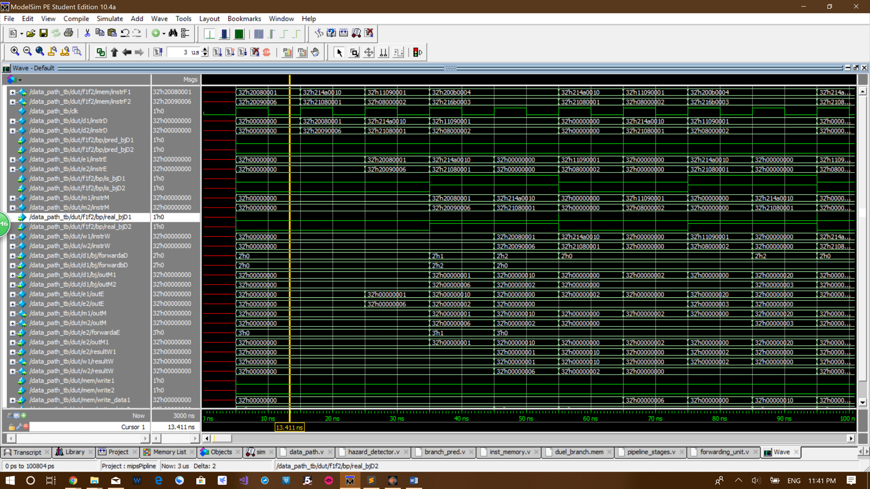**Testing program 1 waveform:**

The cycle number can be easily read from the ns scale. 10ns per cycle, so 70 ns is in the 7th cycle.

As you can see at the first cycle instruction

0x20080001 addi $t0, $zero, 1

0x20090006 addi $t1, $zero, 6

enter the pipeline concurrently shown in signal f1f2/imem/instrF1 and signal f1f2/imem/instrF2.

Everything else have value 0 as expected.

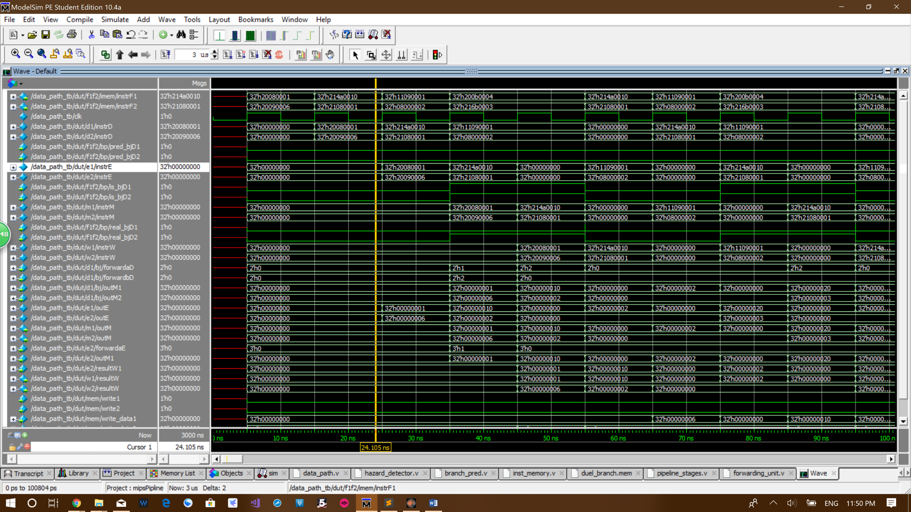

At the second cycle instruction

0x214a0010 addi $t2, $t2, 16

0x21080001 addi $t0, $t0, 1

enter the pipeline concurrently shown in signal f1f2/imem/instrF1 and signal f1f2/imem/instrF2.

Instruction

0x20080001 addi $t0, $zero, 1

0x20090006 addi $t1, $zero, 6

enter the pipeline concurrently shown in signal d1/instrD1 and signal d2/instrD2.

Everything else have value 0 as expected.

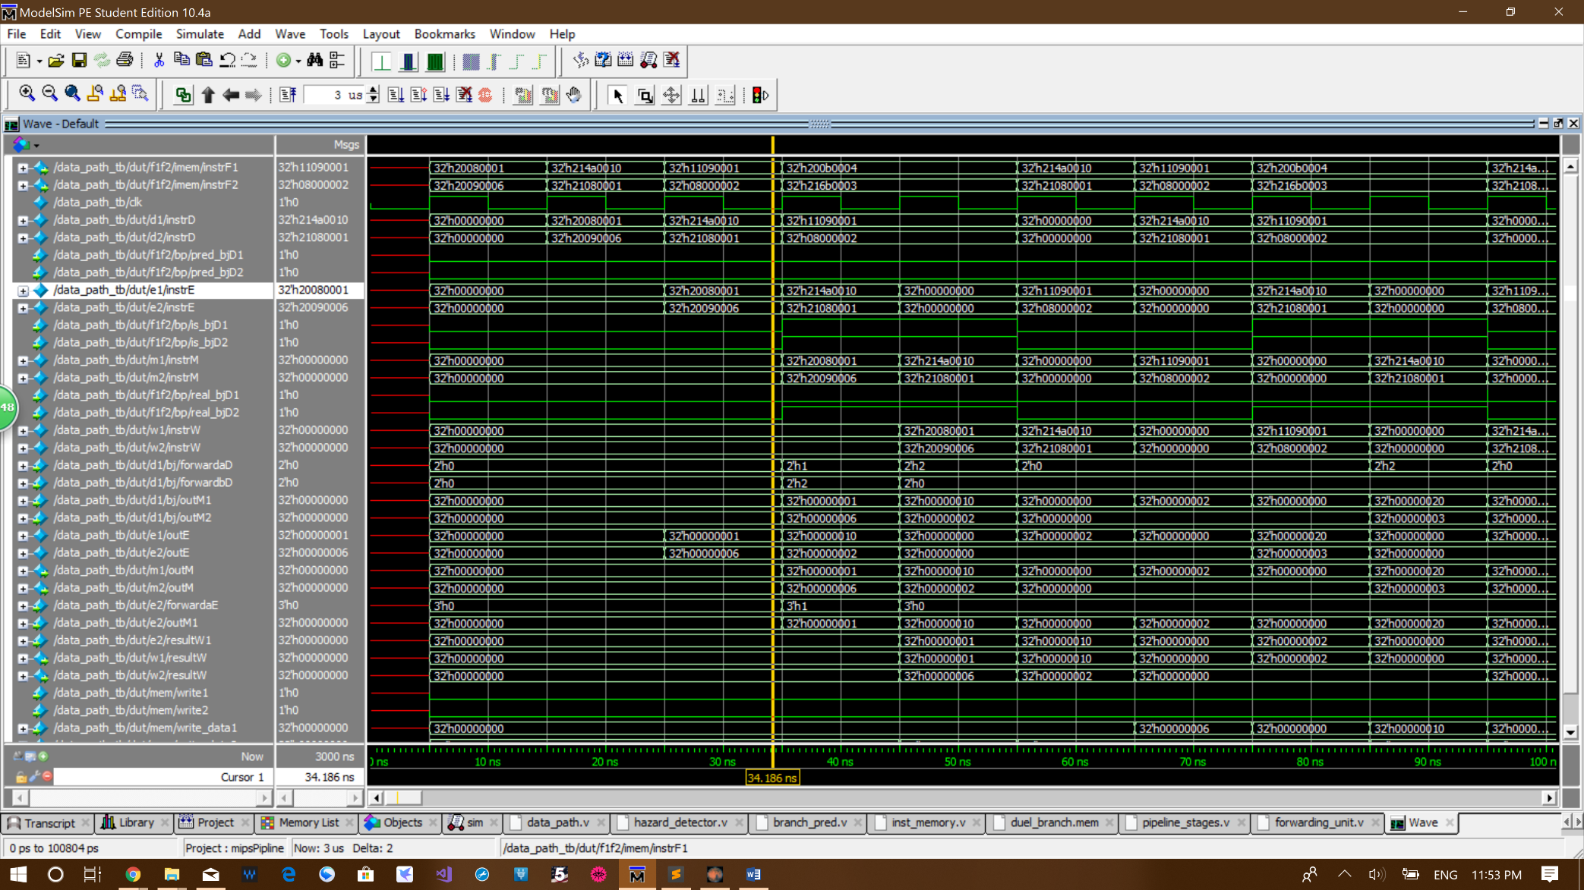

At the thire cycle instruction

0x11090001 beq $t0, $t1, exit

0x08000002 j start

enter the pipeline concurrently shown in signal f1f2/imem/instrF1 and signal f1f2/imem/instrF2.

Instruction

0x214a0010 addi $t2, $t2, 16

0x21080001 addi $t0, $t0, 1

enter the decode stage concurrently shown in signal d1/instrD1 and signal d2/instrD2.

Instruction

0x20080001 addi $t0, $zero, 1

0x20090006 addi $t1, $zero, 6

enter the execution stage concurrently shown in signal e1/instrE1 and signal e2/instrE2.

Everything else have value 0 as expected.

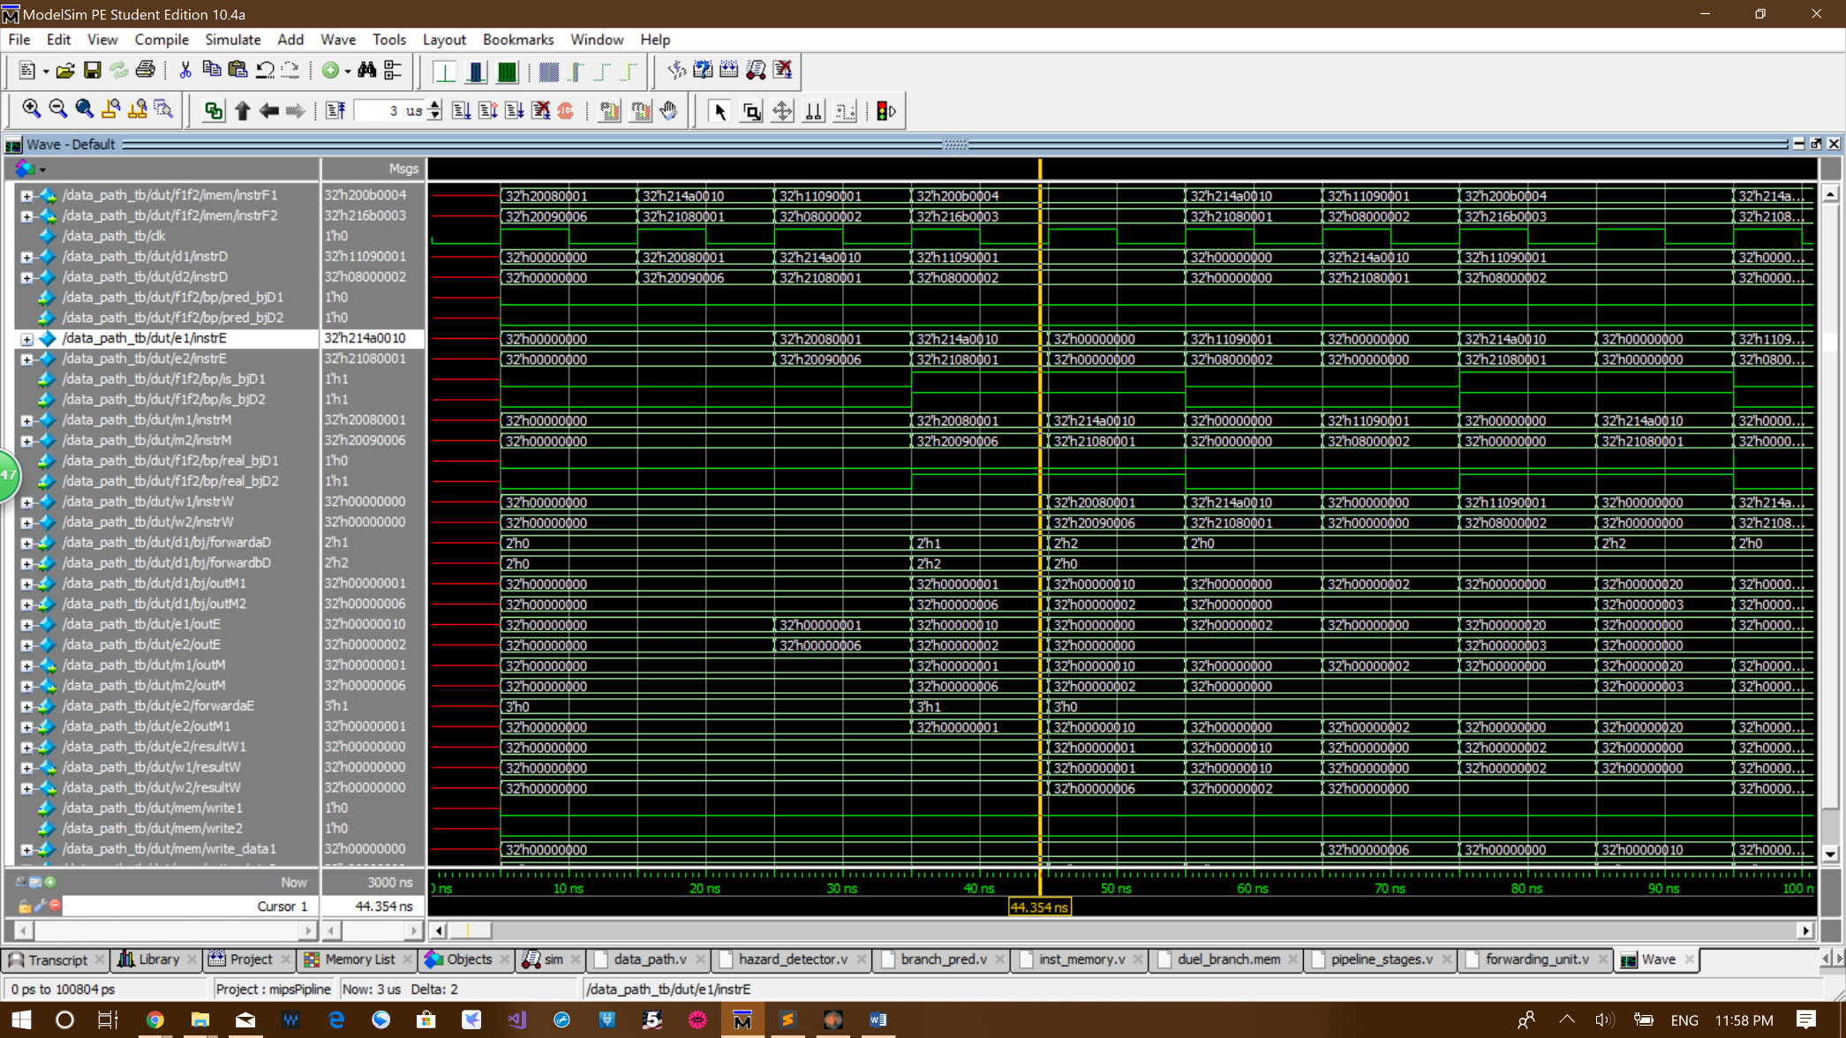

At the 4th cycle instruction

0x200b0004 addi $t3, $zero, 4

0x216b0003 add $t3, $t3, 3

enter the pipeline concurrently shown in signal f1f2/imem/instrF1 and signal f1f2/imem/instrF2. They are not supposed to entire the pipeline, but since the branch predictor predicts every branch not taken before it warms up, the next two lines of instruction enter the pipeline. These two instructions are flushed out of decode stage when the branch is resolved.

Instruction

0x11090001 beq $t0, $t1, exit

0x08000002 j start

enter the decode stage concurrently shown in signal d1/instrD1 and signal d2/instrD2. A branch stall is generated. You can see signal f1f2/bj/is_bjD1 and signal f1f2/bj/is_bjD2 becomes high for two cycles and also the instructions in decode stage does not change for two cycles. This is caused by the dependency between instruction 0x11090001 beq $t0, $t1, exit and 0x21080001 addi $t0, $t0, 1.

Instruction

0x214a0010 addi $t2, $t2, 16

0x21080001 addi $t0, $t0, 1

enter the execution stage concurrently shown in signal e1/instrE1 and signal e2/instrE2. The forwarding from memory stage 1 to execution stage 2 is triggered because of the dependency between 0x21080001 addi $t0, $t0, 1. Signal e1/forwardaE becomes 1. 0 means no forwarding. 1 means forward from outM1. 2 means forward from outM2. As you can see signal m1/outM which is source of the forwarding becomes 1 and signal e2/outM1 which is the receiving end also becomes 1. This means forwarding is successful.

Instruction

0x20080001 addi $t0, $zero, 1

0x20090006 addi $t1, $zero, 6

enter the memory stage concurrently shown in signal m1/instrM1 and signal m2/instrM2. Signal m1/outM forward to e2/outM1 successfully.

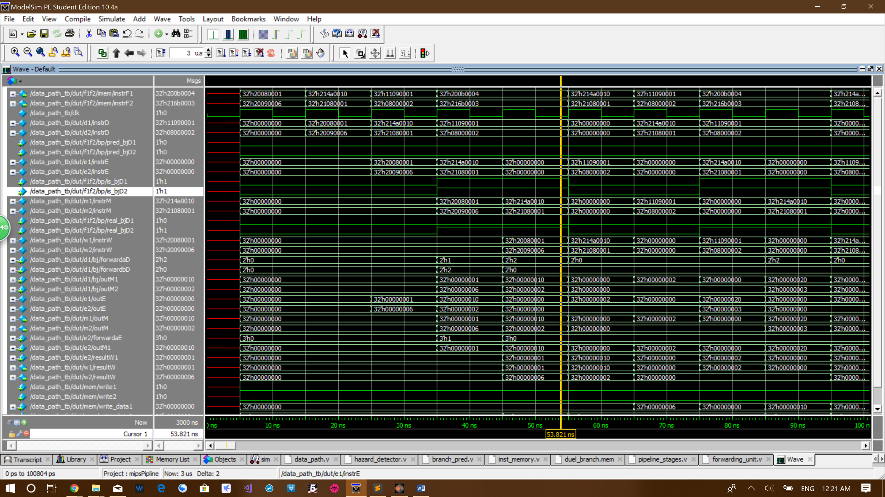

At the 5th cycle instruction

0x200b0004 addi $t3, $zero, 4

0x216b0003 add $t3, $t3, 3

are still stalling in fetch stage shown in signal f1f2/imem/instrF1 and signal f1f2/imem/instrF2.

Instruction

0x11090001 beq $t0, $t1, exit

0x08000002 j start

are still branch stalling in decoded stage shown in signal d1/instrD1 and signal d2/instrD2. Dependency between instruction 0x11090001 beq $t0, $t1, exit and 0x21080001 addi $t0, $t0, 1 is resolved in this cycle. 0x21080001 addi $t0, $t0, 1 enters memory stage 2 and the correct output is forwarded from memory stage 2 to decode stage 1. Signal d1/forwardaD becomes 2. 0 means no forwarding. 1 means forward from outM1. 2 means forward from outM2. As you can see signal m2/outM which is source of the forwarding becomes 2 and signal d1/outM2 which is the receiving end also becomes 2. This means forwarding is successful.

Execution stage if flushed. Signal e1/instrE1 and signal e2/instrE2 becomes 0 in this cycle.

Instruction

0x214a0010 addi $t2, $t2, 16

0x21080001 addi $t0, $t0, 1

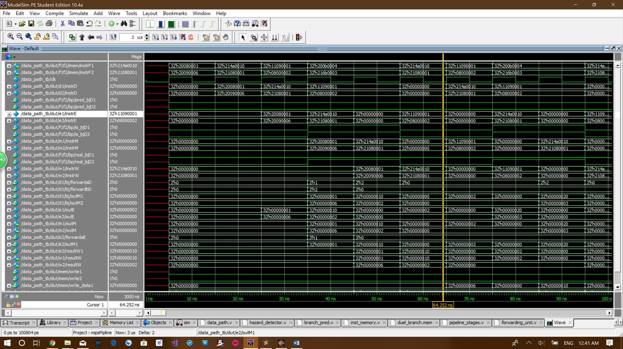enter the memory stage concurrently shown in signal m1/instrM1 and signal m2/instrM2. Signal m2/outM forward to d1/outM2 successfully.

In the 6th cycle the incorrect instruction predicted by branch predictor

0x200b0004 addi $t3, $zero, 4

0x216b0003 add $t3, $t3, 3

are replaced by the correct instructions

0x214a0010 addi $t2, $t2, 16

0x21080001 addi $t0, $t0, 1

in fetch stage shown in signal f1f2/imem/instrF1 and signal f1f2/imem/instrF2.

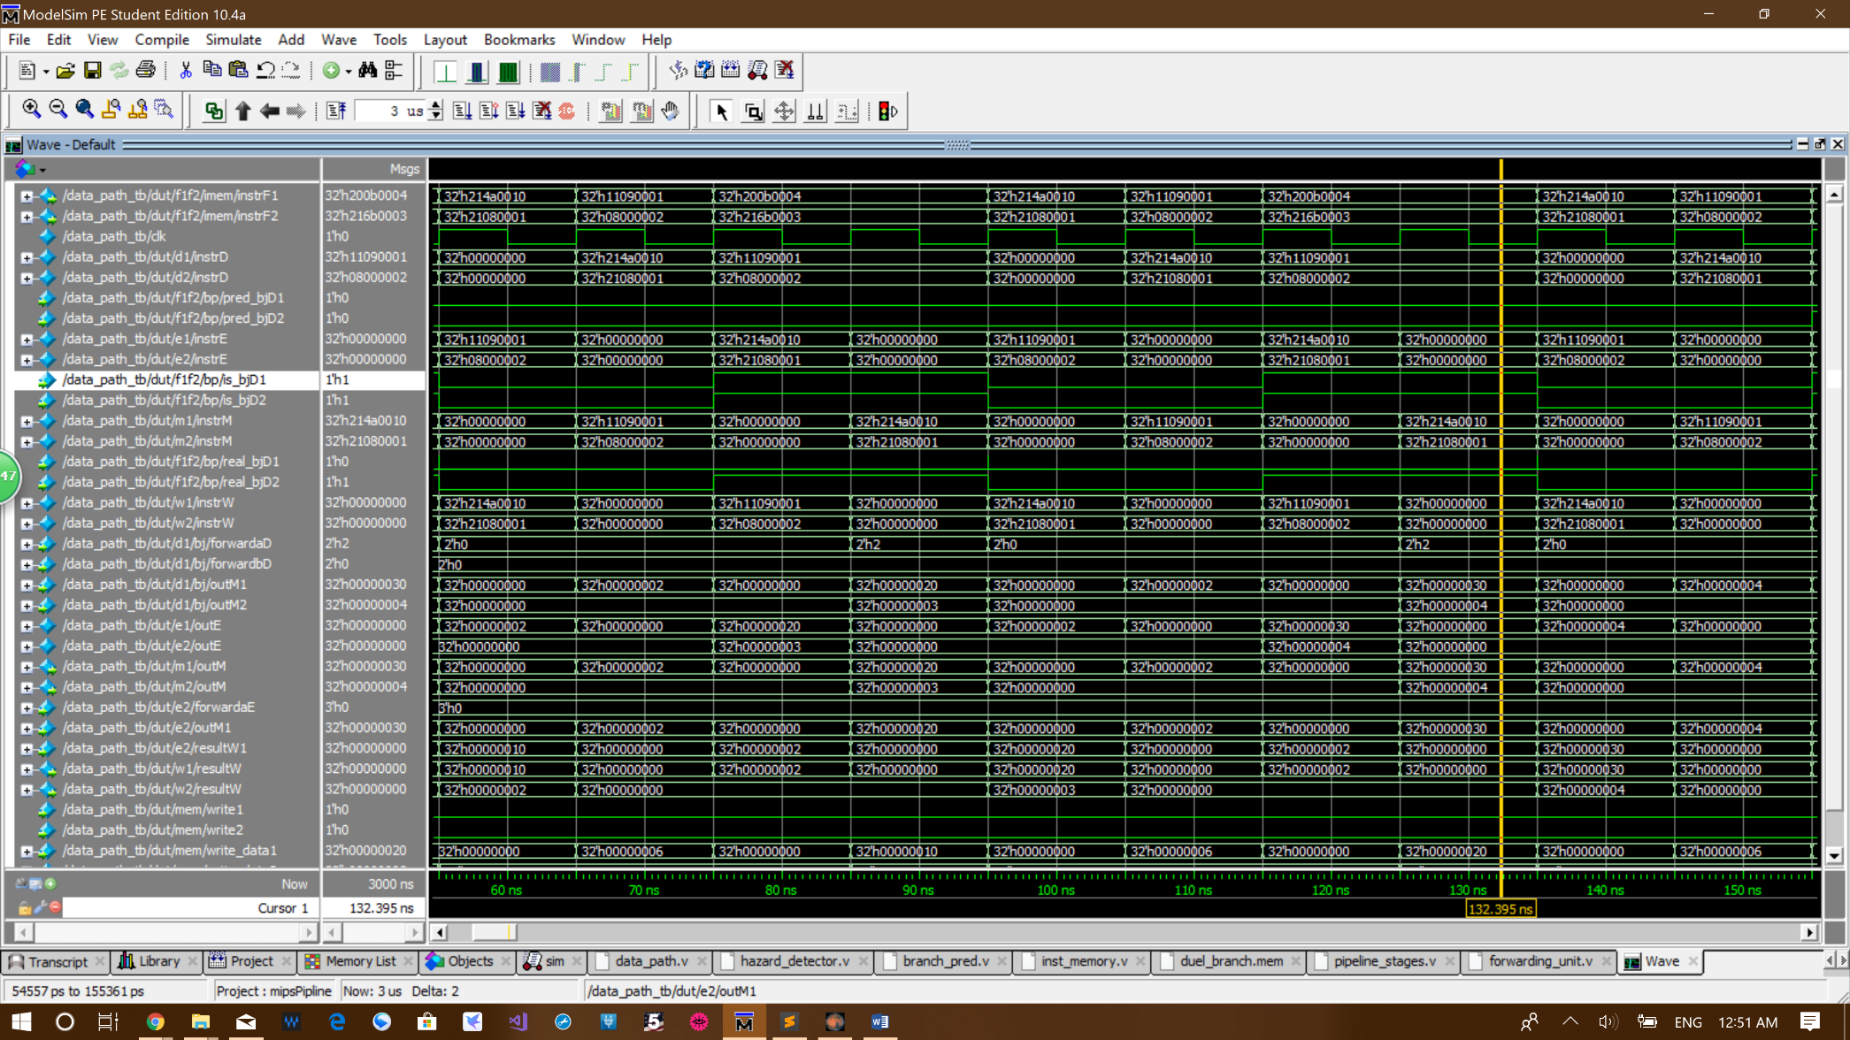Decoded stage is flushed by branch predictor. Signal d1/instrD1 and signal d2/instrD2 becomes 0 at this cycle.

Now the state of the first few stages of the pipeline becomes the same as it was in the third cycle. The 6th cycle to the 13th cycle is just repeating cycle 3,4 and 5 for two times.

As you can see, up till now the branch predictor have not yet predicted a branch, but the repeating before the 13th cycle warms up the branch predictor.

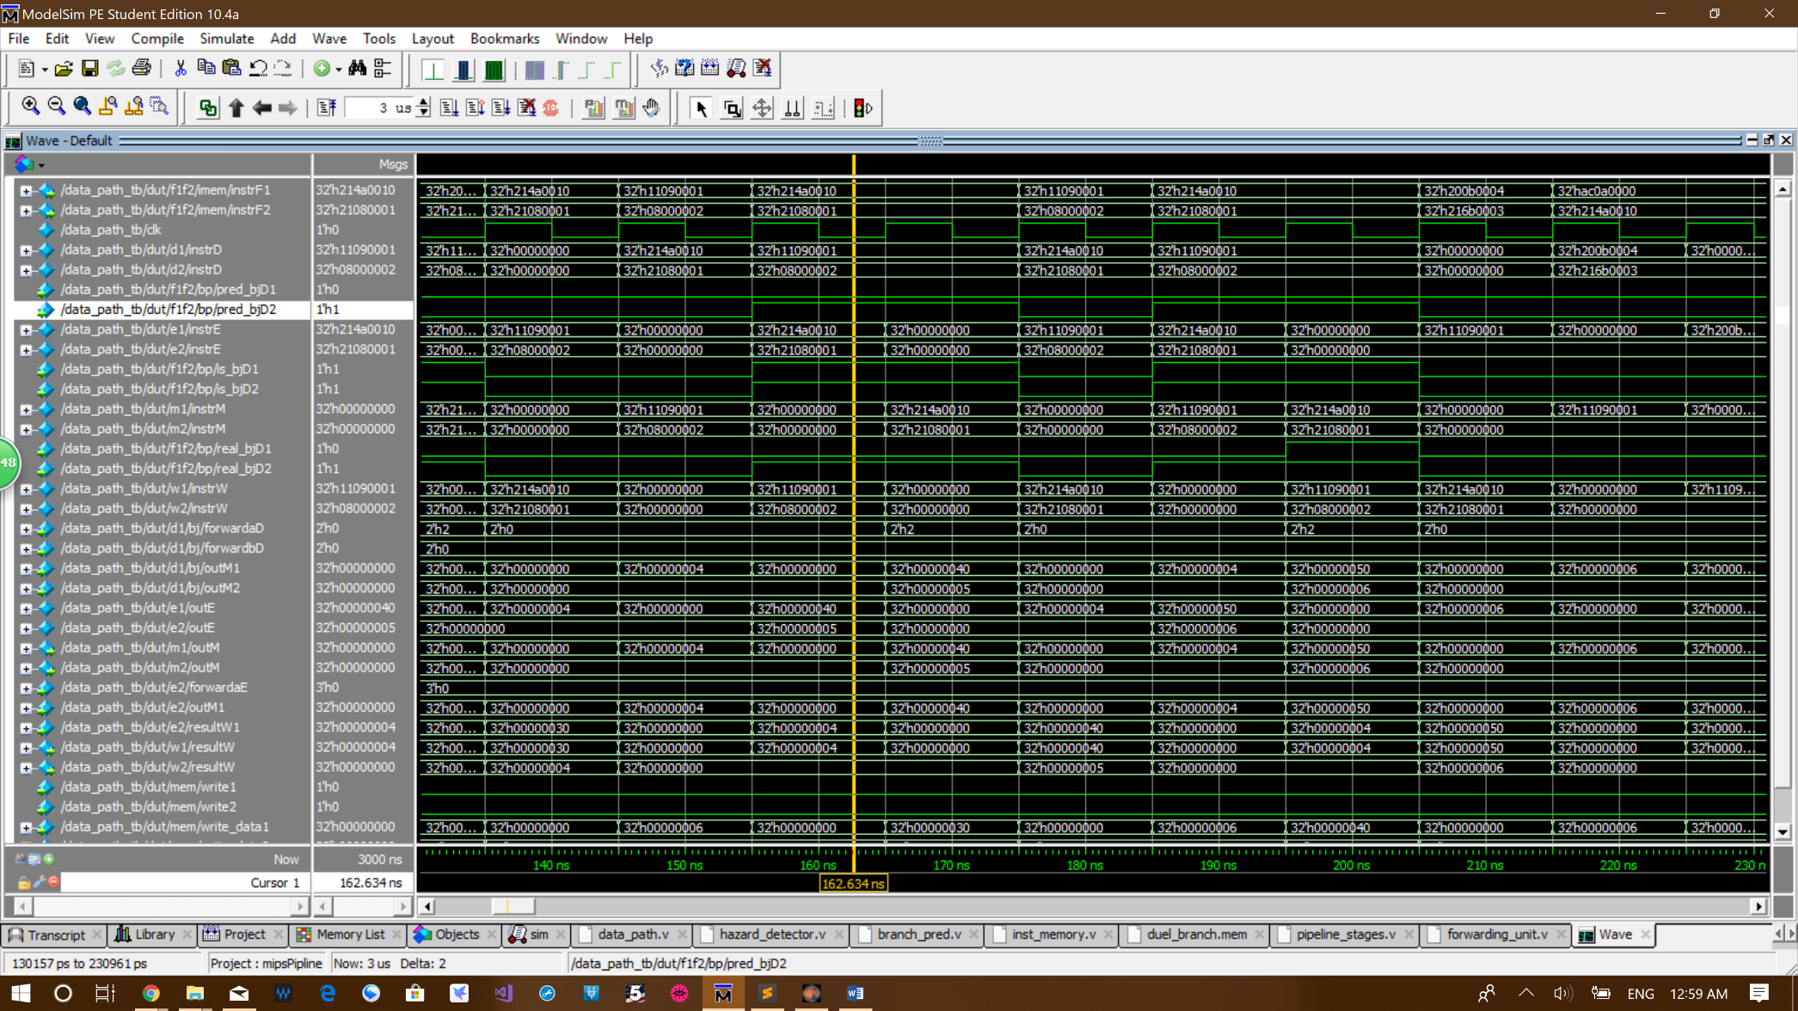

The branch predictor finally warmed up and produced the correct prediction at cycle 16. Look at signal f1f2/imem/instrF1 and signal f1f2/imem/instrF2. Before now instruction

0x214a0010 addi $t2, $t2, 16 and 0x21080001 addi $t0, $t0, 1

is followed by instruction

0x11090001 beq $t0, $t1, exit and 0x08000002 j start

then by two wrong instruction

0x200b0004 addi $t3, $zero, 4 and 0x216b0003 add $t3, $t3, 3

However, this time the correct instruction

0x214a0010 addi $t2, $t2, 16 and 0x21080001 addi $t0, $t0, 1

comes into fetch stage right after instruction

0x11090001 beq $t0, $t1, exit and 0x08000002 j start

As you can see from signal /f1f2/bp/pred_bjD2, the branch predictor correctly predicts this jump will be taken.

It takes exactly three times before the branch predictor produce the correct result. The reason is that the first time jump is taken, the value in global history table is 00, which is different from any value that follows, so this jump is wasted. The second and third time the jump is taken all have global history table value of 01, since there is exactly 1 beq not taken and 1 jump taken before that. After the third jump the saturation counter value becomes 10, which mean the 4th times branch predictor is able to predict the jump correctly.

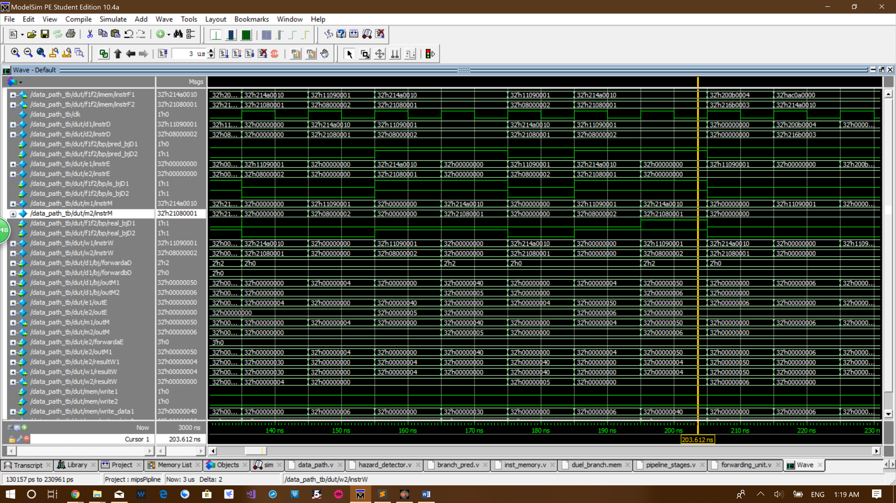

At the 19th cycle instruction

0x214a0010 addi $t2, $t2, 16

0x21080001 addi $t0, $t0, 1

are put in the fetch stage shown in signal f1f2/imem/instrF1 and signal f1f2/imem/instrF2. However, these are not the correct instructions any longer, because this times the beq needs to be taken, which mean jump right after it will not be taken. You can see the correct instruction

0x200b0004 addi $t3, $zero, 4

0x216b0003 add $t3, $t3, 3

are put into fetch stage after the branch stall is over. You can see the signal f1f2/bp/real_bjD1 is 0 at cycle 19, but changes to 1 when the correct value is forwarded at cycle 20. Dependency between instruction 0x11090001 beq $t0, $t1, exit and 0x21080001 addi $t0, $t0, 1 is resolved in cycle 20. 0x21080001 addi $t0, $t0, 1 enters memory stage 2 and the correct output is forwarded from memory stage 2 to decode stage 1. Signal d1/forwardaD becomes 2. 0 means no forwarding. 1 means forward from outM1. 2 means forward from outM2. As you can see signal m2/outM which is source of the forwarding becomes 6 and signal d1/outM2 which is the receiving end also becomes 6. This means forwarding is successful. The value becomes 6, so the branch is taken.

The prediction is wrong, so decode stages are flushed in the 21th cycle. As you can see both signal d1/instrD1 and signal d2/instrD2 become 0 in cycle 21.

Execution stage if flushed. Signal e1/instrE1 and signal e2/instrE2 becomes 0 in this cycle.

Instruction

0x11090001 beq $t0, $t1, exit

0x08000002 j start

are still branch stalling in decoded stage shown in signal d1/instrD1 and signal d2/instrD2. Dependency between instruction 0x11090001 beq $t0, $t1, exit and 0x21080001 addi $t0, $t0, 1 is resolved in this cycle. 0x21080001 addi $t0, $t0, 1 enters memory stage 2 and the correct out put is forwarded from memory stage 2 to decode stage 1. Signal d1/forwardaD becomes 2. 0 means no forwarding. 1 means forward from outM1. 2 means forward from outM2. As you can see signal m2/outM which is source of the forwarding becomes 2 and signal d1/outM2 which is the receiving end also becomes 2. This means forwarding is successful.

Execution stage 2 is also if flushed. By looking at e1/instrE1 and signal e2/instrE2 in the 21 cycle. Instruction 0x11090001 beq $t0, $t1, exit is still going down the pipeline, but insertion 0x08000002 j start disappeared. Although letting jump goes into execution stage is not a problem, this behavior is to prevent other instruction like add to enter the execution stage when the branch in decode stage1 is taken and instruction in decode stage 2 is not suppose to be calculated.

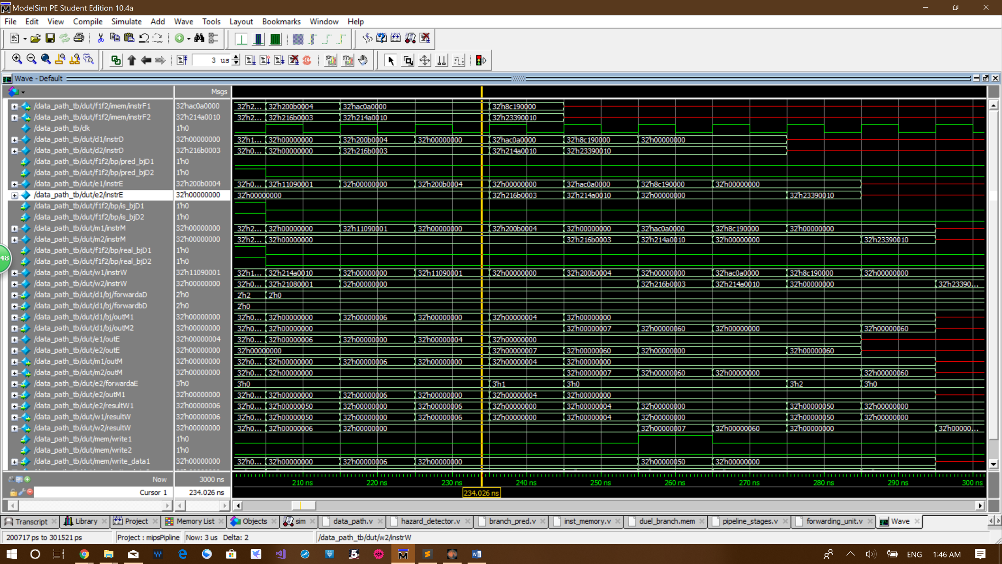

Instruction

0x200b0004 addi $t3, $zero, 4

0x216b0003 add $t3, $t3, 3

enters the fetch stage at cycle 21. Then they propagate to decode concurrently at cycle 22. Since 0x200b0004 addi $t3, $zero, 4 and 0x216b0003 add $t3, $t3, 3 have dependency, 0x216b0003 add $t3, $t3, 3 has to be stalled in the decode stage and let only 0x200b0004 addi $t3, $zero, 4 enter execution. At cycle 23, only 0x200b0004 addi $t3, $zero, 4 propagated to the execution stage and decode stage 1 is flushed as you can see that d1/instrD becomes 0.

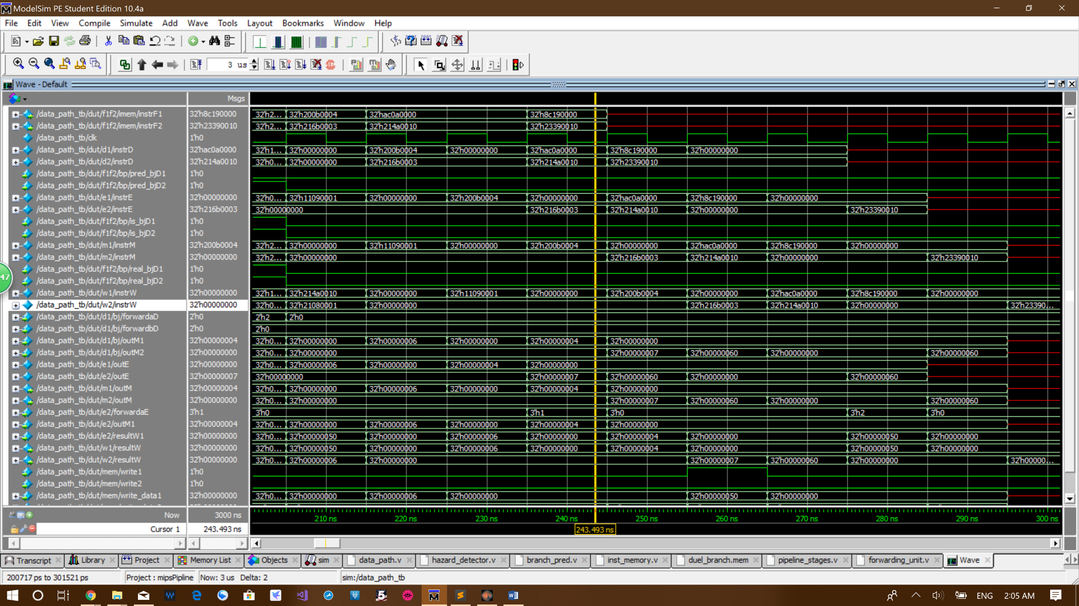The forwarding happens in the cycle 24. As you can see signal e2/instrE becomes 0x216b0003 and signal m1/instrM becomes 0x200b0004. The signal e2/forwardaE becomes 1 at cycle 24. 0 means no forwarding. 1 means forwarded from outM1. 2 means forwarded from resultW1. 3 means forwarded from outM2. 4 means forwarded from resultW2. The signal e2/outM1 and m1/outM both have value 4 at cycle 24. The means the forwarding is successful.

At cycle 22, instruction

0xac0a0000 sw $t2, 0($zero)

0x214a0010 addi $t2, $t2, 16

enter the fetch stage, but they are stalled for 1 cycle because instruction 0x216b0003 add $t3, $t3, 3 is stalled for 1 cycle.

The last two instruction

0x8c190000 lw $t9, 0($zero)

0x23390010 addi $t9, $t9, 16

enter the fetch stage at cycle 23.

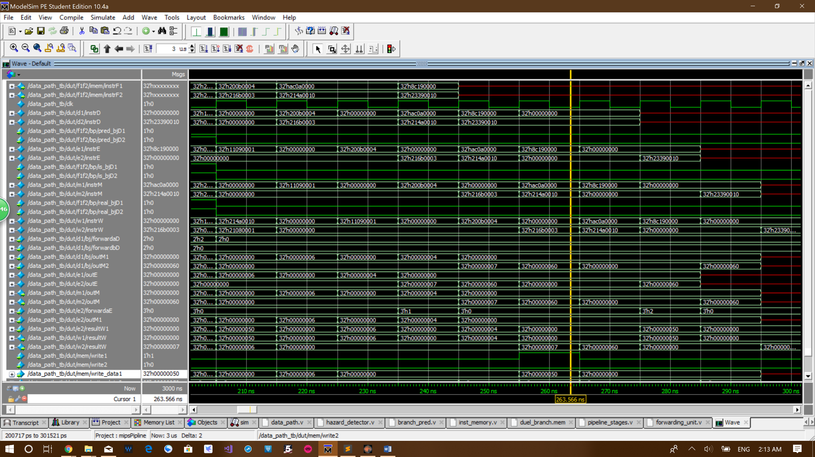

At cycle 26, instruction 0xac0a0000 sw $t2, 0($zero) store the word 50 in to the memory, shown by signal mem/write_data1 and signal mem/write1. Then lw loads the word at the next cycle.

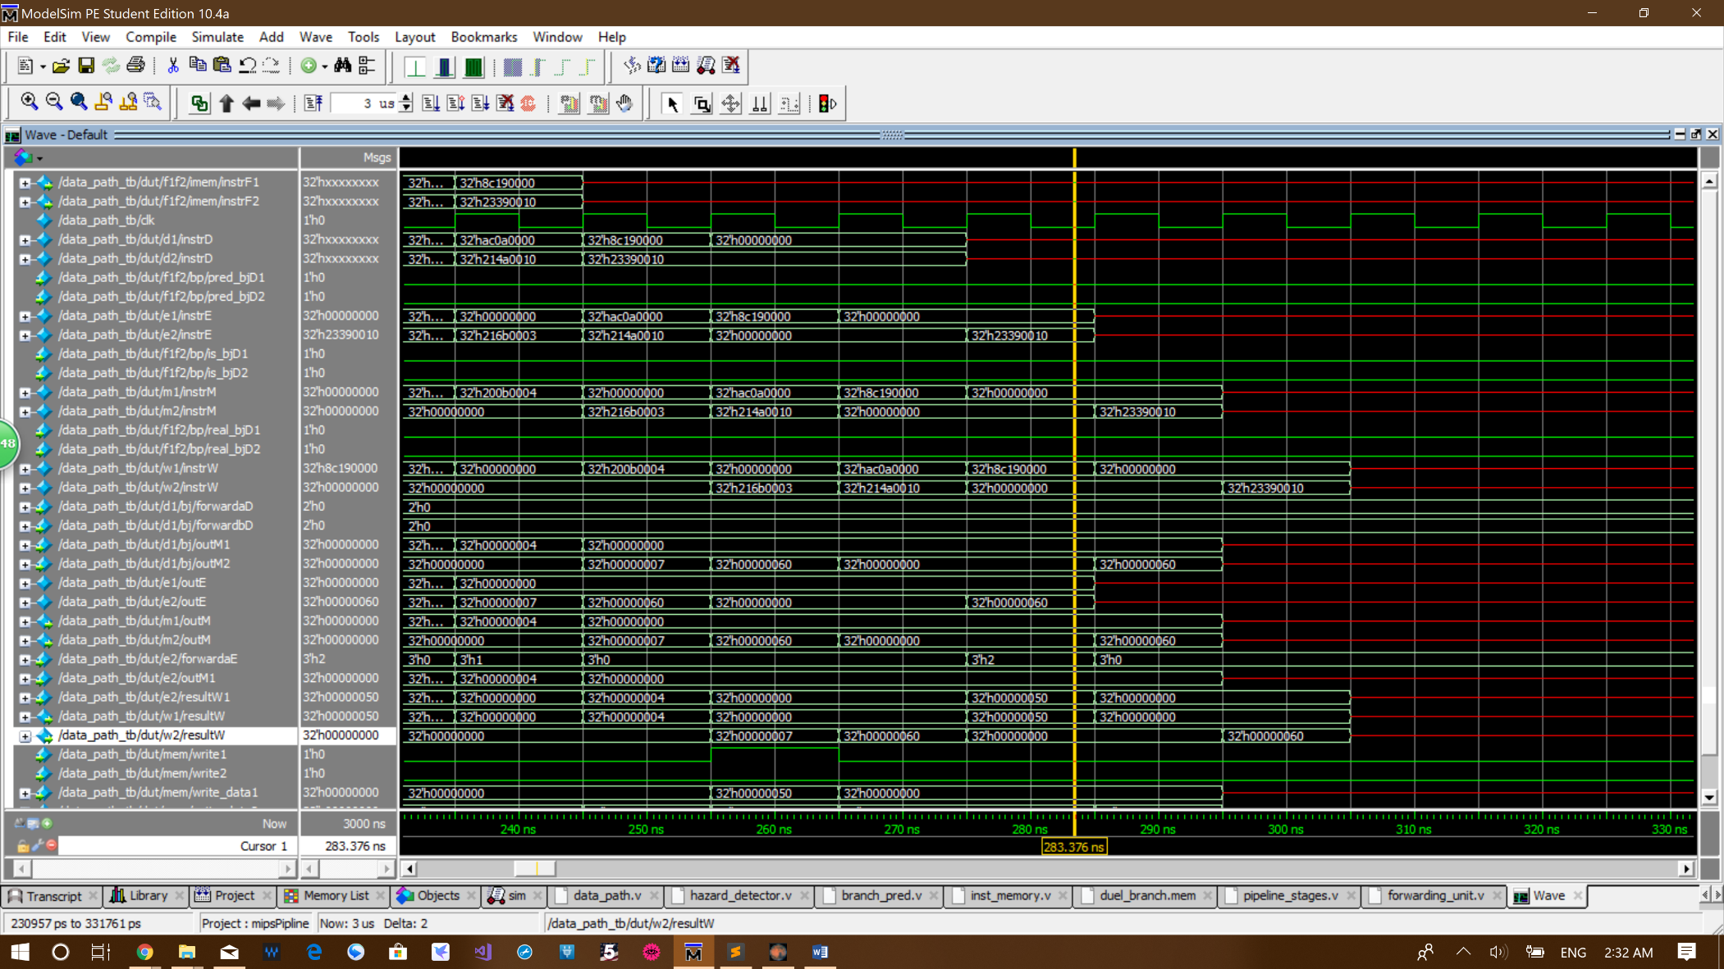

Since instruction 0x8c190000 lw $t9, 0($zero) and 0x23390010 addi $t9, $t9, 16 have dependency, load word stall must stall instruction 0x23390010 addi $t9, $t9, 16 at decode stage 2 for two cycles. As you can see from signal d1/instrD, instruction 0x23390010 addi $t9, $t9, 16 stays in decode stage 2 for 3 cycles in total. At cycle 26, instruction 0x8c190000 lw $t9, 0($zero) is propagated to the execution stage and decode stage 1 and execution stage2 are flushed. These two stages continue to flush until cycle 28, when instruction 0x23390010 addi $t9, $t9, 16 propagates to execution stage.

At cycle 28 instruction 0x8c190000 lw $t9, 0($zero) and 0x23390010 is at the write back stage, so the data is forwarded from write back stage 1 to execution stage 2. As you can see signal e2/forwardaE have value 2. 0 means no forwarding. 1 means forwarded from outM1. 2 means forwarded from resultW1. 3 means forwarded from outM2. Also signal w1/resultW and e2/resultW1 all have value 50. The means the forwarding is successful.

The result of instruction 0x23390010 addi $t9, $t9, 16 is finally written into register file at cycle 30. As you can see signal w2/result become 60 at cycle 30.

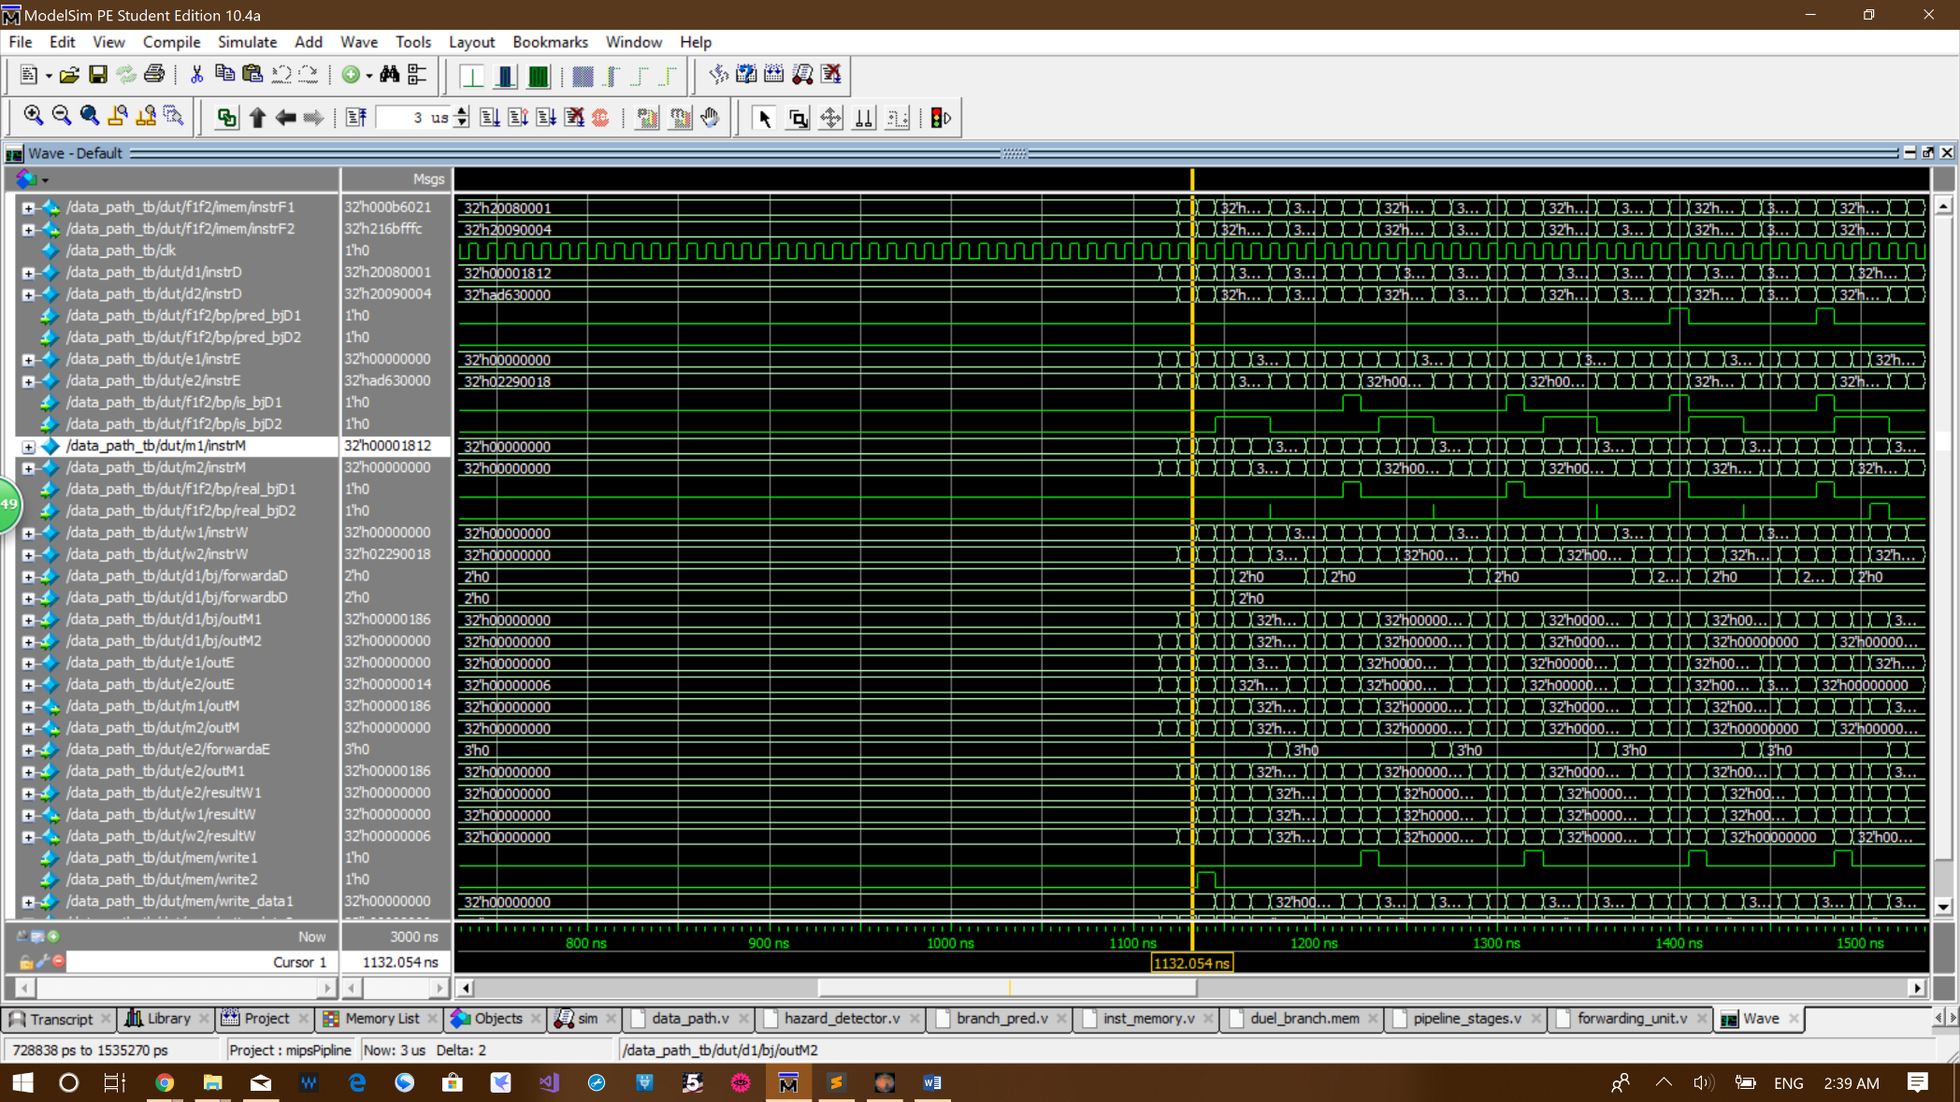**Testing program 2 waveform:**

As you can see from the signal /m1/instrM, 1 cycle before the place where the yellow curser is instruction 0x02290018 mult $s1, $t1 is performed in the execution stage 2. 1 cycle after that instruction 0x00001812 mflo $v1 comes into execution stage. And another cycle after that, where the yellow cursor is, the value of the lo register is loaded out. As you can see the signal m1/outM have value 0x186 which is exactly 0x4e * 0x5.

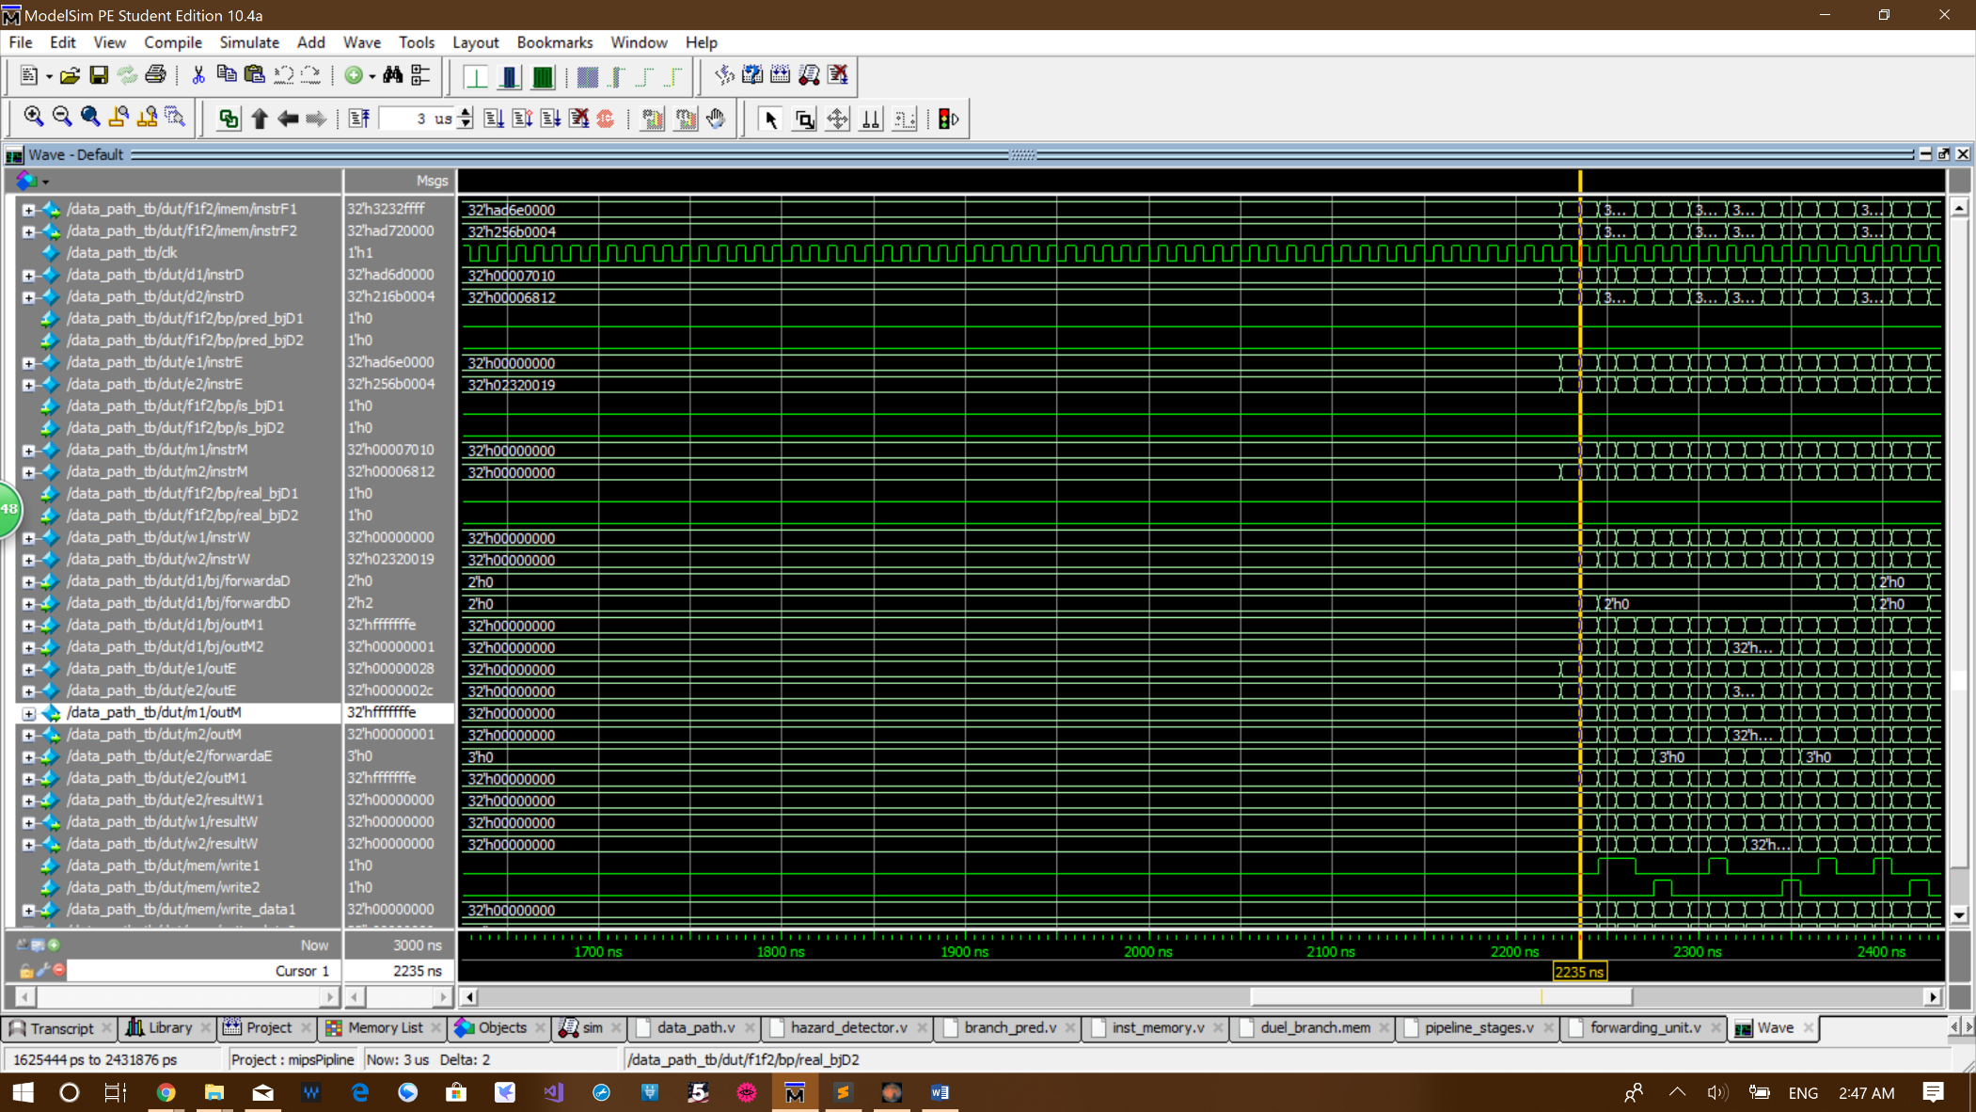

0x02320019 multu $s1, $s2

0x00007010 mfhi $t6

0x00006812 mflo $t5

As you can see from the signal /m1/instrM, 1 cycle before the place where the yellow curser is instruction 0x02320019 multu $s1, $s2 is performed in the execution stage 2. 1 cycle after that instruction 0x00007010 mfhi $t60x00001812 and mflo $v1 come into execution stage concurrently. And another cycle after that, where the yellow cursor is, the value of the lo and hi register is loaded out. As you can see the signal m1/outM, which is the value of hi regeister, have value 0xfffffffe and signal m2/outM, which is the value of lo regeister, have value 0x00000001. 0xffffffff * 0xffffffff = 0xfffffffe00000001.

**Conclusion:**

The superscalar MIPS processor we designed have ever component in the signal-issue 5-stage MIPS processor duplicated except program counter, instruction memory, register file and data memory. To make the dual-issue superscalar MIPS processor major changes must be made to the branch predictor, hazard unit, forwarding unit.

The dual-issue superscalar MIPS processor is implemented with a branch predictor. The dual-issue superscalar MIPS processor ideally issues two instructions per cycle. **We did the extra credit mult and multu instructions.** We spend around 48 hours in total for this project.